Historic Tale Construction Kit

Point your browser to the following Internet address:

http://www.adgame-wonderland.de/type/bayeux.php

Allow time for the application to download in the browser. The following screen will appear. Click on Start in the bottom left hand corner.

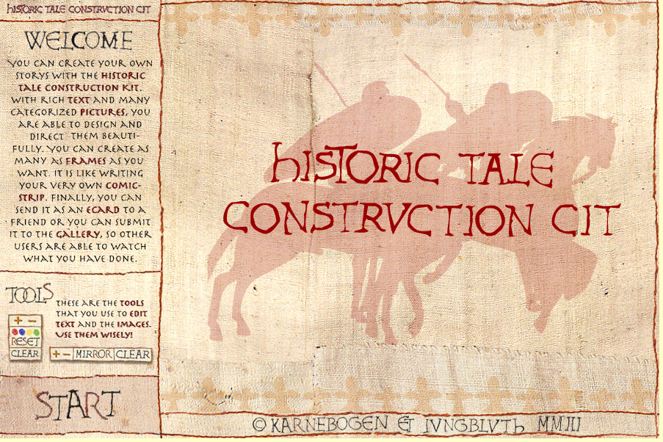

The following image will appear. Click on the Image button and explore each of the images available: Folc, Brave, Beasts, Buildings and Misc.

Decide which characters and objects you will use and plan out a story with 3 or more scenes. You may use rich or poor people, priests or knights. Do not forget to use buildings, trees and animals as well.

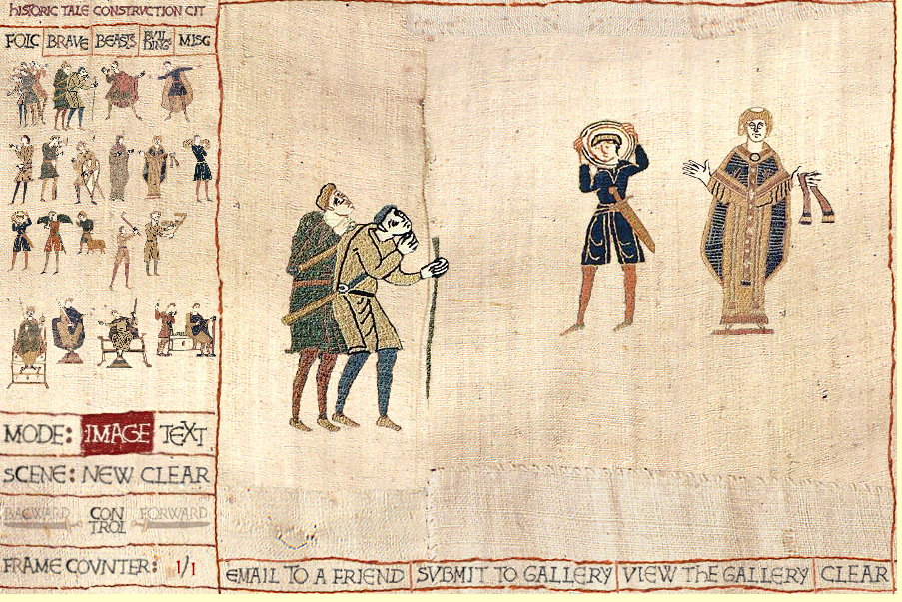

Drag the images on to the construction area at right. You can move the characters, buildings and other objects around the screen.

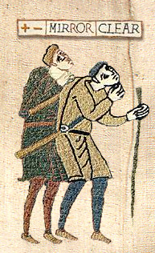 | 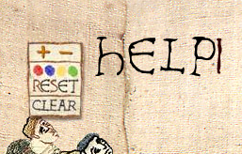  Click on the Text button at left to add text to the image. Remember that you can also use Comic Life to add word or thought balloons. You can increase and decrease the size of the text as well as change its colour. You can also Clear the text if you wish to change it.  Do not use the Shift key to create an upper case letter. No letter will appear.
You can increase or decrease the size of the image by clicking on the minus or plus buttons. You can also flip the image by clicking on the mirror button. If you do not wish to use the image click on the Clear button.

When you have completed the scene you can save it to your Desktop by typing Command–Shift 4 and selecting the area that you wish to keep. You can also type Shift Apple 4. You can drag the crosshairs to select the area that you wish to use. If you make a mistake simply try once more and delete the incorrect image on your desktop.

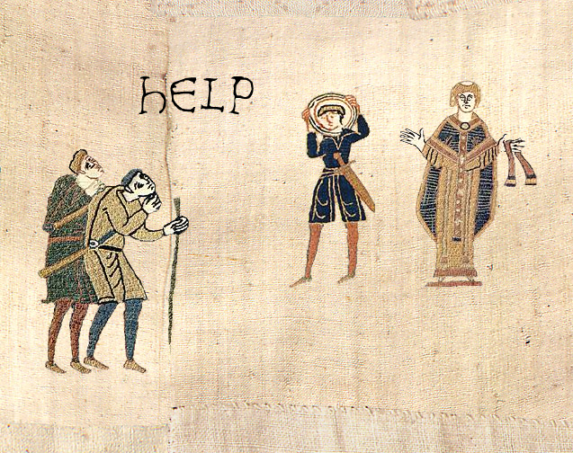

Save all of you scenes to a folder on your computer and then back up those images. You can add them to Comic Life.

