Setting up a Blog

Why set up a web log or ‘blog’?

A blog can allow you to rapidly share your ideas, experiences and questions with others. The point is that you have an opportunity to express yourself and this can help you to crystallise your thoughts and to put your subject matter into perspective. You can generate discussions and provide opportunities for problem based learning experiences. As you develop experience you can set up class and group blogs with your students.

You can read more about why it is useful to set up an educational blog by following these links:

Weblogg-ed: Why web log? http://www.weblogg-ed.com/why-weblogs

Around the corner ~ Miguel Guhlin: Why blog? http://www.edsupport.cc/mguhlin/archives/2007/07/entry_3414.htm

The Open Clasroom: Why blog with students: http://theopenclassroom.blogspot.com/2007/07/why-blog-with-students-its-to-do-with.html

The Bamboo Project: http://michelemartin.typepad.com/thebambooprojectblog/2007/08/preaching-to-em.html

Using Blogs To Promote Authentic Learning In The Classroom: http://web20intheclassroom.blogspot.com/2008/01/blogging-in-classroom-why-how-and-lots.html

Where can I start?

There are several companies that allow you to easily set up a blog. Some are free while others are not. Here are some of the more recognised solutions:

Blogger. Google hosts this service. It is easy to use and there are ad-ons to increase the versatility of the blog. The service is free. Blogger will be used in this workshop. http://www.blogger.com/start |  | 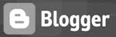
Edublogs: A blogging tool with teachers and students in mind. It uses the Wordpress blogging engine. http://edublogs.org/  Ably supported by the Edublogger: http://theedublogger.edublogs.org/ |  | 
Wordpress.com A highly polished and professional blogging tool. Allows you to set up your own blog and static web pages online.  http://wordpress.com/ |  | 
Wordpress.org Download the Wordpress software and host your own blog on your web server. Allows you to set up your own blog and static web pages.
http://wordpress.org/
Posterous. This is the easiest blogging tool of all. Set up is simple. One can post via email. Embedding galleries, audio and video is as simple as adding an email attachment or link. http://www.posterous.com/ |  | 

Setting up a Blog

For this exercise the Blogger software will be utilised. Open a web browser such as Internet Explorer and type this url in the address bar.

http://www.blogger.com/

Your browser will take you to this page.

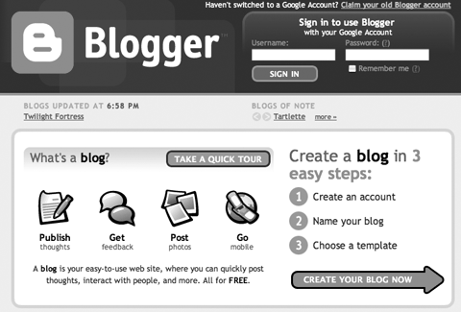

You could take the Quick Tour to explore the possibilities of blogging. After you have finished the tour you could then create your own blog which simply involves:

- Creating an account.
- Naming your blog.
- Choosing a template.

Click on the button “Create Your Blog Now”.
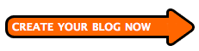
Creating an account

After you have clicked on the “Create Your Blog Now” button you will be taken to the screen where you can complete your account details. Remember to make a note of your username and password if you do not have a particularly strong memory.

Please not, if you already have a Gmail account with Google, please click on the “sign in first” link at the end of the first paragraph of the screen illustrated below

Email address: You may use your work email address or a personal email address. That is up to you. Professionally I use the same email address for my log-ins whenever possible. It is one less item that I need to remember. And, remember, if you have a Gmail email account click on the “sign in first” link at the end of the first paragraph of the screen illustrated below.

Password: Choose a password that is meaningful, easily remembered and difficult for anyone else to guess. Do not use a PIN or password that you use for banking or online financial transactions. Try to keep that aspect of your life separate from an online presence.

Display name: This is the name that will appear with each blog post.

Do not forget complete the Word Verification and to click on the Acceptance of Terms checkbox.

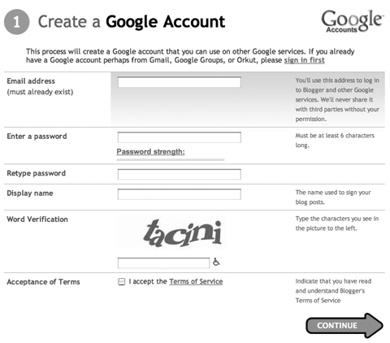

After you have completed the details click on the “Continue” button.
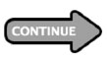
Naming your blog

After you have clicked on the “Continue” button you will be taken to the screen where you can name the blog. This is a chance to be creative. A number of ideas will spring to mind however do not be surprised if they are all taken. The title of your blog may directly relate to your teaching area or research interests. In the example below I have completed the following details:

Title: Web 2.0 Workshop
Blog address: http://webtwoworkshop.blogspot.com/
Is your blog address available?

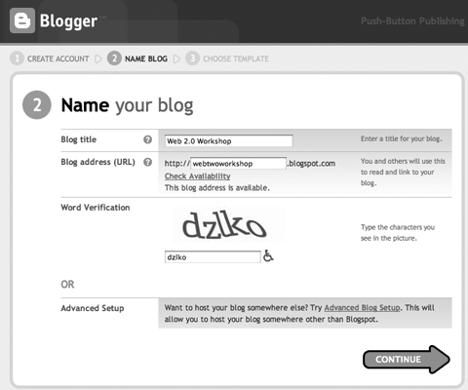

You have the opportunity to have your blog hosted on your own web server. You will need to click on the Advanced Blog Setup link to explore that possibility. Once you have completed the word verification field then click on the “Continue” button.

Choosing a template

After you have clicked on the “Continue” button you will be taken to the screen where you can choose a template. There are a number of templates available. Once you have established your blog there are even more template possibilities.

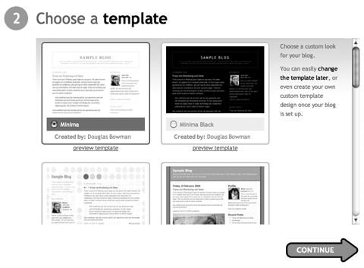

Once you have selected a template click on the “Continue” Button.

You will see a temporary splash screen that announces that your blog is being created.

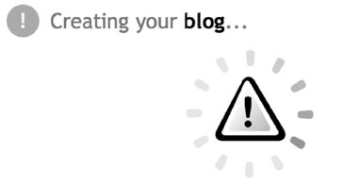
Your blog is created

Your online presence now has a beginning; you will be taken to this screen once the blog has been published.

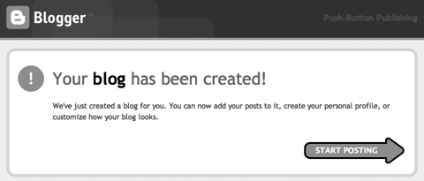

Click on the Start Posting button to write your first post.

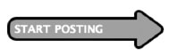

Entering your first post

You will be taken to a screen where you can enter your first post. Type in some ideas. You can preview the post and even add a picture if you wish. Click on “Publish Post”.

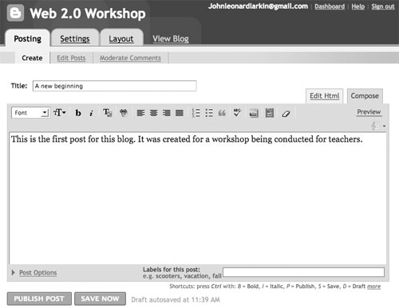

You will then come to this screen:

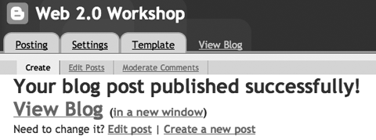

Click on “View Blog” to see the first post.

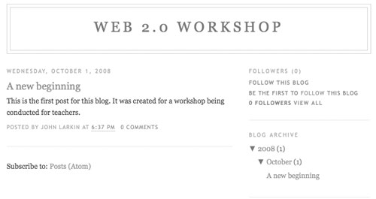

You should now customise your blog and set a number of preferences or options for your blog. Click on your browsers “Back” button to return to the previous screen so that we can begin.
Setting your preferences

Click on the Settings tab.

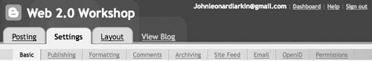

You can alter quite a few settings in Blogger. It is a good idea to explore each in turn to see what they offer.

Basic settings

Title: You can change the title of your blog at any time.

Description: Enter a description of your blog. This is a summary of your blog’s content. Your objectives or wishes may be expressed here. People that visit your blog will see this description and immediately know what it is all about.

Add your blog to our listings: Do you wish that you blog be listed by blogger for others to find? Make your choice here.

Let search engines find your blog: Do you want others to find your blog? Make your choice here.

Show quick editing on your blog?: This is a good idea. Click yes and if you notice a typo or error within a blog post you can quickly edit the post as you view the blog.

Show email post links: Click on Yes. This allows visitors to quickly email a link to your blog post to others. This can assist in increasing readership of your blog.

Adult Content: Select “No”

Show Compose mode for all your blogs: This should be set to Yes. This allows you to create and edit posts easily using a word processor type functionality.

Enable transliteration. This setting adds a button to the toolbar for converting words from English to the selected language. You may later change the language in the Post Editor.

You can also Delete your blog if you wish.

Click on the “Save Settings” button at the foot of the web page if you make a change.

Publishing

At this tab you can choose where you wish to publish your blog. You can leave it at blogpsot.com or if you have space on a server you can direct it to that address. You can point a domain to your blog as well.
You can even change the website address of your blog if you decide that the name needs to be changed.

Click on the “Save Settings” button at the foot of the web page if you make a change.

Formatting

Explore the possibilities here. Make sure you have set the correct time zone. You can leave most of the settings as is.

Show link fields. Change this to Yes so the podcast enclosures and other links can be included as part of the post.

Click on the “Save Settings” button at the foot of the web page if you make a change.

Comments

There are a number of settings I recommend that you change. Let’s look at each in turn:

- Comments. Select the “Show” button.
- Who can comment? You can select ‘anyone’ however if you wish the blog to be used only by your class or a specific research group you could enter these as members. In that case you could select the option “only members of this blog”. Click on the Permissions link above to enable users.
- Comment default for posts: New Posts have comments.
- Backlinks: Select “Show”. This will reveal who has linked to your blog post.
- Backlinks default for posts: New Posts have backlinks.
- Show comments in a popup window: Select “No”.
- Enable comment moderation. Click “Yes” if you wish to verify comments before they are published online. I highly recommend that this be set to “Yes” if you wish to control what is published on your blog.
- Show word verification for comments: Select “Yes”. This will stop automated spamming systems.
- Comment notification email: If someone leaves a comment on your blog you will be notified at the email address that you type in here.
- Show profile images on comments. You can set this to Yes if you do not mind seeing the image that represents the individual that left the comment.
- Comment notification email. This allows others to inform others that comments have been made to the blog. This is useful if the blog has multiple authors.

Click on the “Save Settings” button at the foot of the web page if you make a change.

Archiving

Leave these settings as is. It is wise to archive your posts monthly.

Enable Post Pages. Select Yes as this will give each post its own unique Internet address that others can link to.

Click on the “Save Settings” button at the foot of the web page if you make a change.

Site Feed

This allows your site to be picked up by news readers. When you choose to activate Atom syndication, Blogger will automatically generate a machine-readable representation of your blog that can be picked up and displayed on other web sites, software, and gadgets. Your students will probably use news readers. This will give them quick access to the contents of your blog. Leave the Allow Site Feed setting at Full.

If you replace this blog with another you can add its RSS feed address to the Post Feed Redirect URL.
Click on the “Save Settings” button at the foot of the web page if you make a change.
Email

You can leave the BlogSend Address blank unless you have members who can also post to the blog. You can post to your blog via email if your complete the Mail-To-Blog Address.

Create a suitable, easily remembered, email address and make a note of it. You can then use your favourite email software to easily post to your blog. You simply compose your blog entry in a new email and send it to the email address that you create here. This is a very handy feature.

Click on the “Save Settings” button at the foot of the web page if you make a change.

OpenID

If you have an OpenID account you can link your blog to it.

Click on the “Save Settings” button at the foot of the web page if you make a change.

Permissions

This is where you add members to your blog. You could add colleagues or students to the blog.

Blog Authors: You can invite additional authors to your blog.
Blog readers: You can determine who reads your blog. As you can see by clicking on the various choices you have a great deal of control over how public your blog can be.

Click on the “Save Settings” button at the foot of the web page if you make a change.

Changing your template

You can alter the look and feel of your blog by directly editing the html code. You can also choose another template. Click on the Template tab and the Page Elements tab. You will see the following screen.

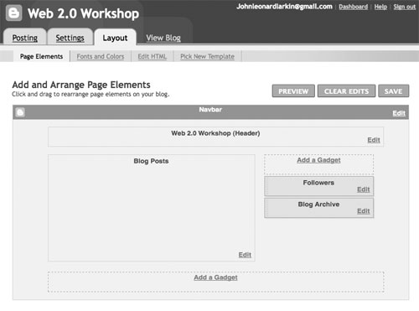

You can alter the look and feel of your blog and add a variety of page elements by clicking on the Add a Gadget link.

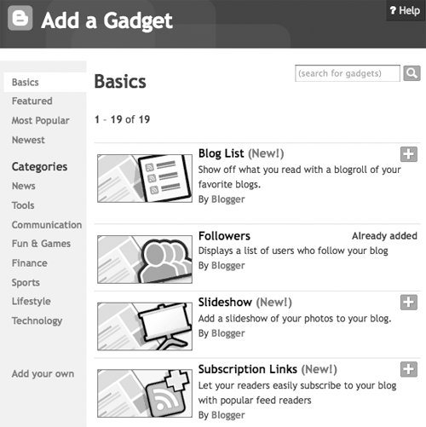

This feature will be utilised during the workshop. I suggest that you add the Subscription Links, Labels and Archive gadgets to your blog to get started.

Fonts and Colours: You can alter the colour scheme for your blog. Tread carefully.

Pick New Template: Choose a new template.

Edit HTML: If you are confident with direct html editing you can modify the appearance of your blog at this expert level.

Updating your profile

You can now update your profile and add a photograph for your blog. Click on the “Back to Dashboard” button.

You will come to the dashboard page where you can change the ‘global’ settings for your blogger account.

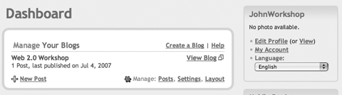

You will see this set of choices:

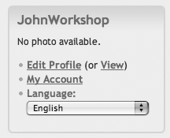

Click on the Edit Profile link to modify your profile description. You can enter details about yourself. You do not have to enter in all of the options if you wish to maintain a sense of anonymity. You can also change the language for your blog.

Start blogging

Start making entries and add photographs as well. Each time you log in you can simply click on the ‘New Post’ button to quickly get started.

