Setting up a Google Account together with Google Reader and iGoogle

Google Reader allows you to keep track of the various web logs that you have subscribed to in the past. In this manner you can easily keep track of any new posts in the various web logs. In order to take advantage of Google Reader you need to have a Google account. Simply follow the steps below.

Launch a web browser application such as Internet Explorer, Firefox or Safari. Type the following address in the web address field.

www.google.com

You will see the following window…

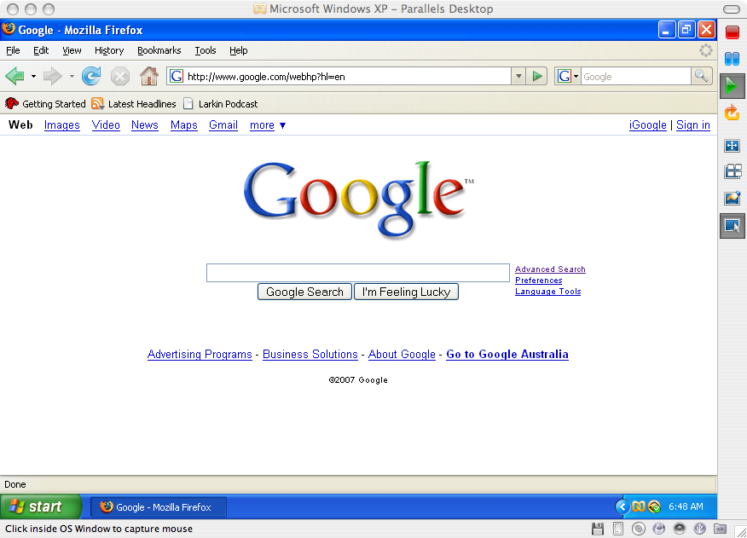

Click on the Sign In link located in the upper right hand corner of the Google window. The following window will appear.

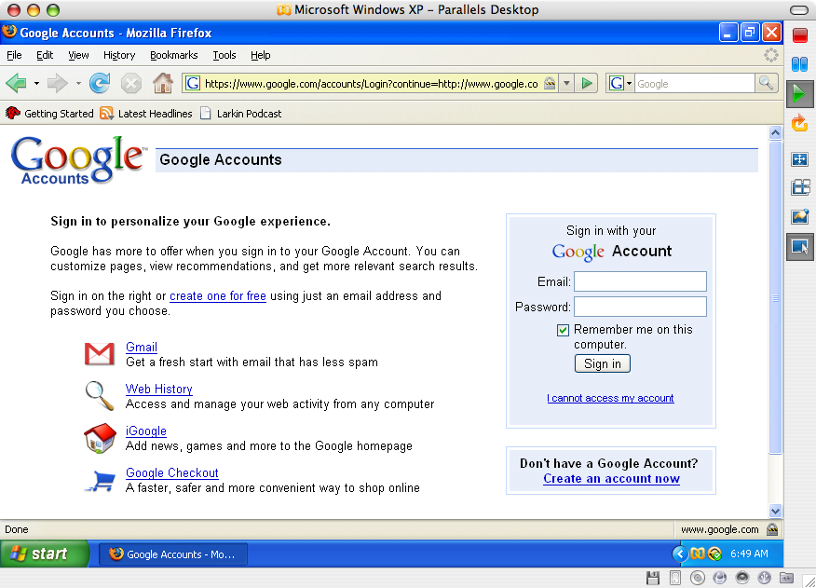

If you already possess a Google account simply sign in. If not, click on the Create an account now link in the bottom right hand corner of the window. The following window will appear.

Complete the details required to set up the account. Follow the instructions on each window step by step.

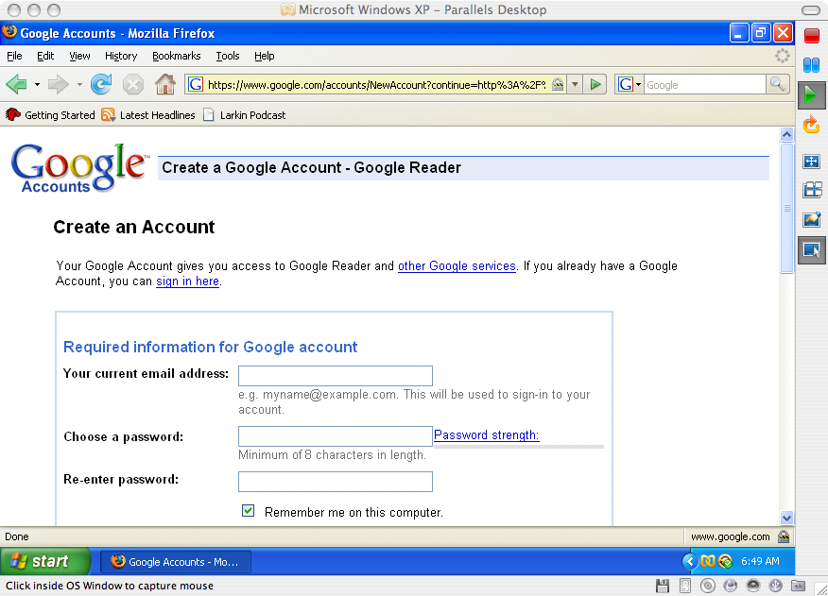

Once you have created the account return to the main Google page at www.google.com. Are you still signed in?

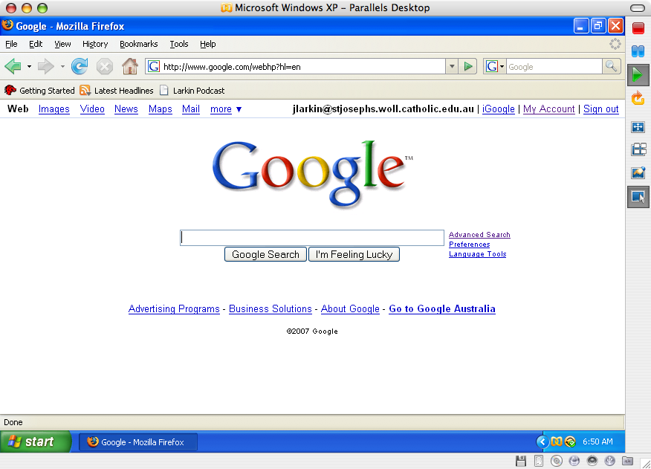

Setting Up Google Reader

Select Reader from the more drop down menu at the top of the Google window.

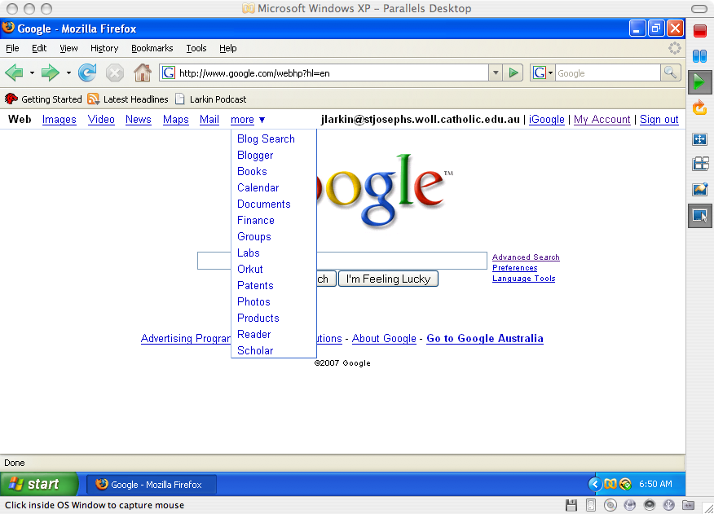

You will see the following window. This is the main Google Reader window with its introductory video. Feel free to view the video.

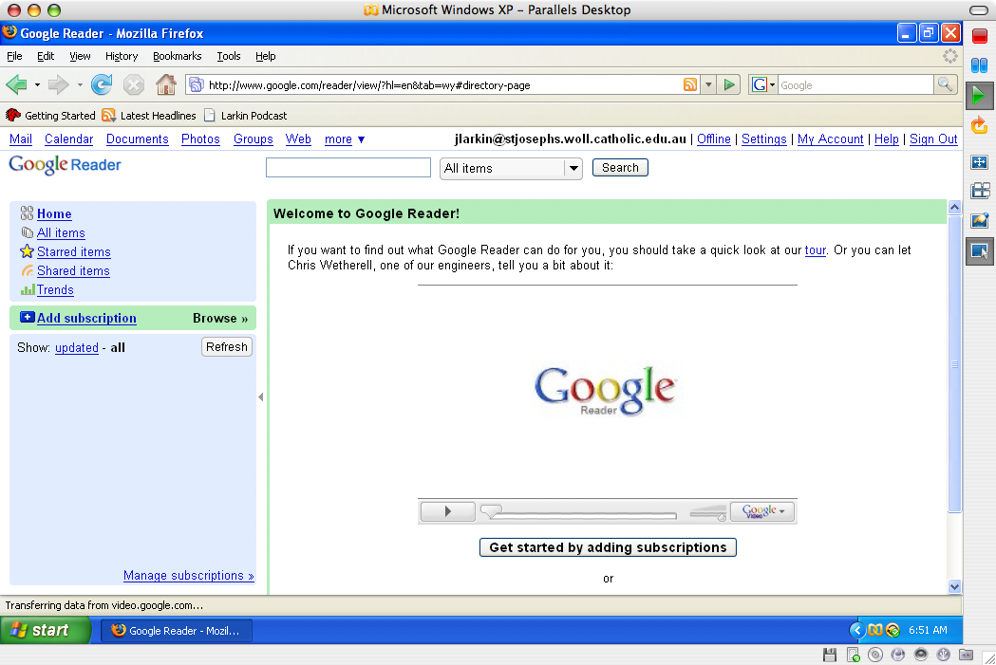

Click on the Settings link at the top of the Google Reader window. You will see the window below.

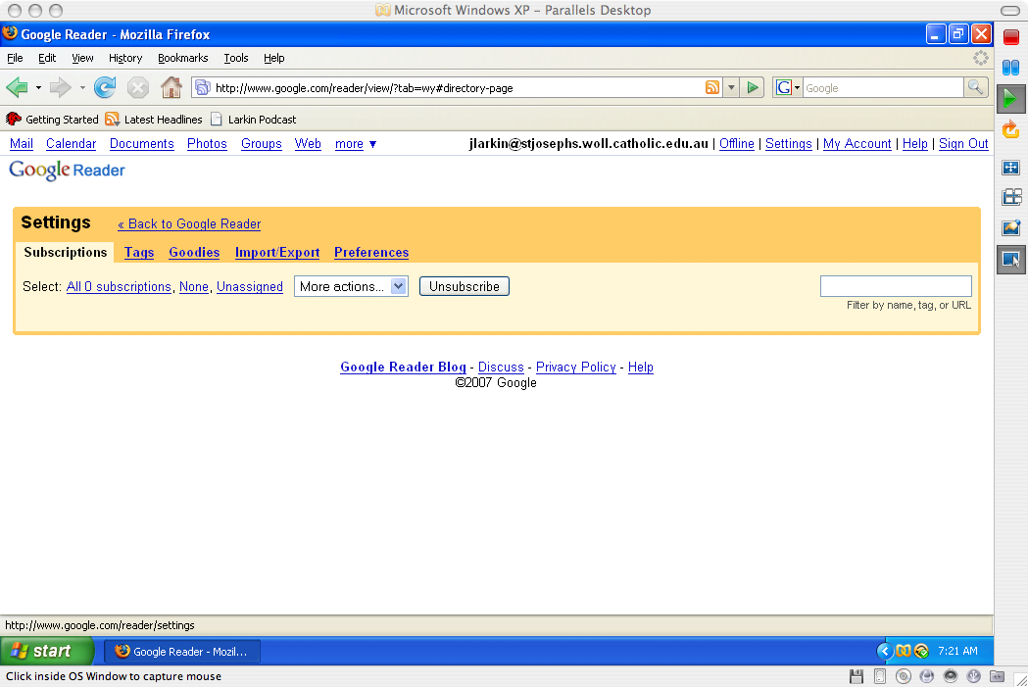

This window allows you to configure Google Reader. At this stage there are no subscriptions in your Google Reader. Please click on the Goodies link. You will see the following window.

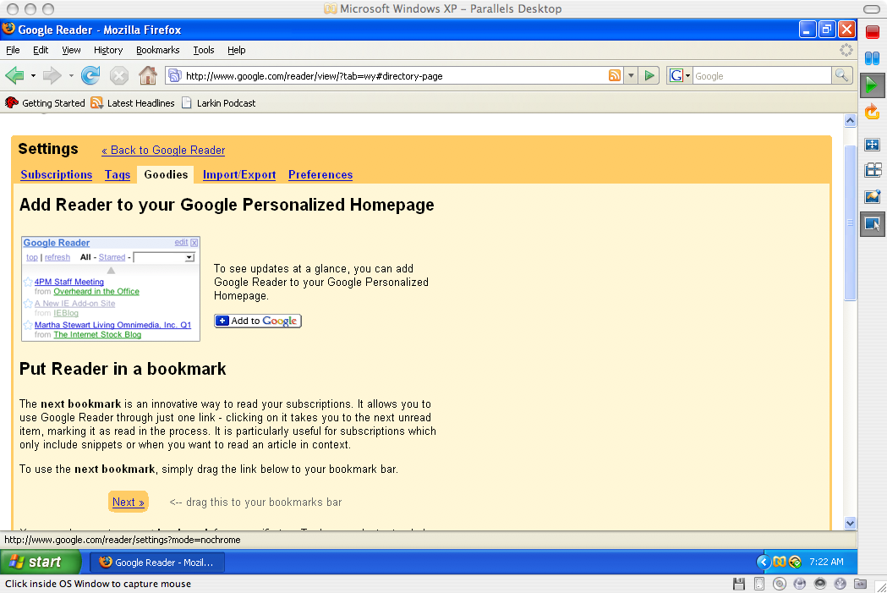

There are two very useful tools available for your use here. Read the information about adding Google Reader to your personalised Google Home Page. This places a widget on your personalised Google home page. This is very useful. The other is the “Subscribe as you surf” button. Scroll down the screen to see the following information.

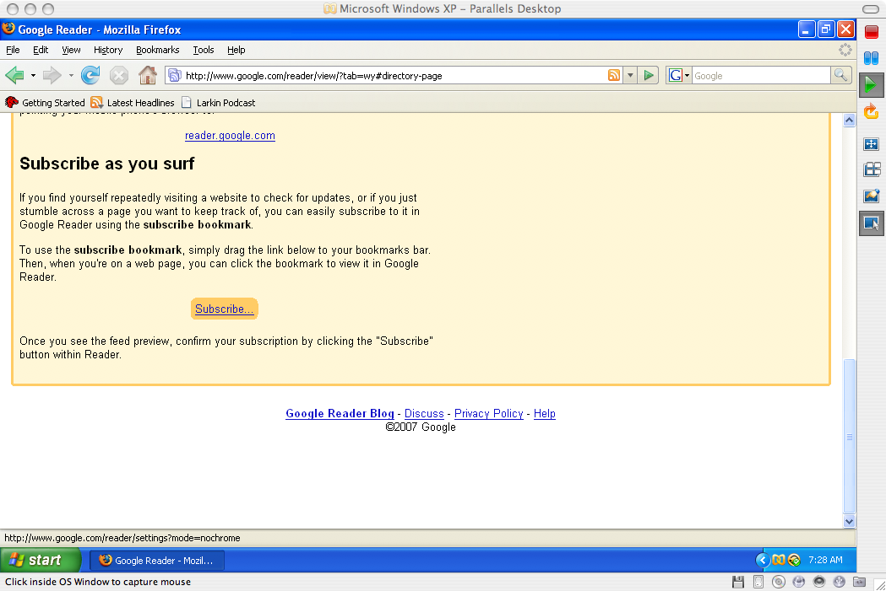

Follow the instructions provided on the page. Drag the Subscribe button to the Bookmarks Bar of Firefox, Safari or the latest version of Internet Explorer. This button will be indispensable as you add web log subscriptions to Google Reader.
As you can see from the window below the Subscribe button has been added to the Firefox Bookmarks Bar.

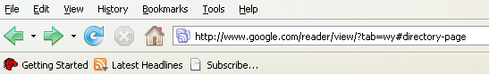

Setting Up A Google Home Page

Click on the My Account link at the top of the Google Window. The following window will appear.

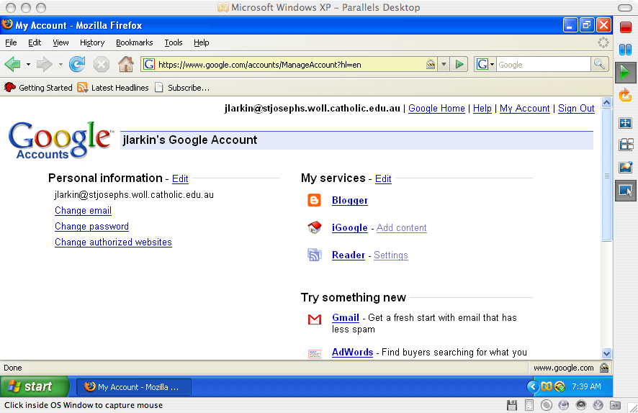

Click on the iGoogle link on the right hand side of the Google Account window. The following window will appear.

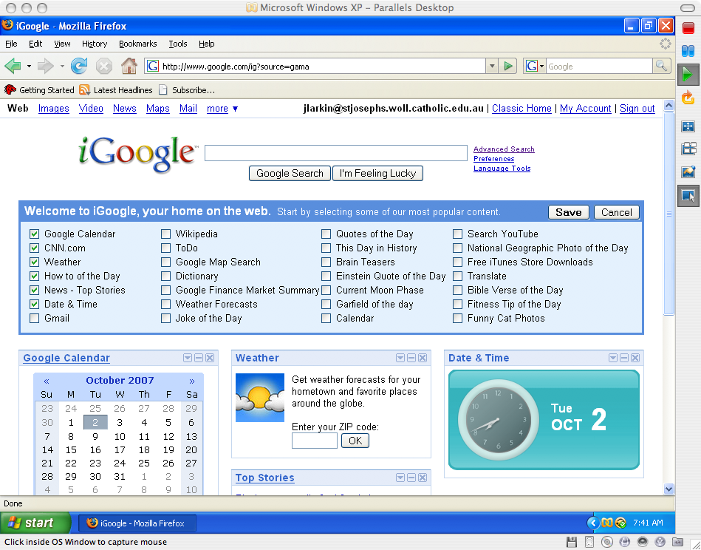

To begin creating your iGoogle Home Page, click on the Save button located on the right hand side of the iGoogle window. The following window will appear.
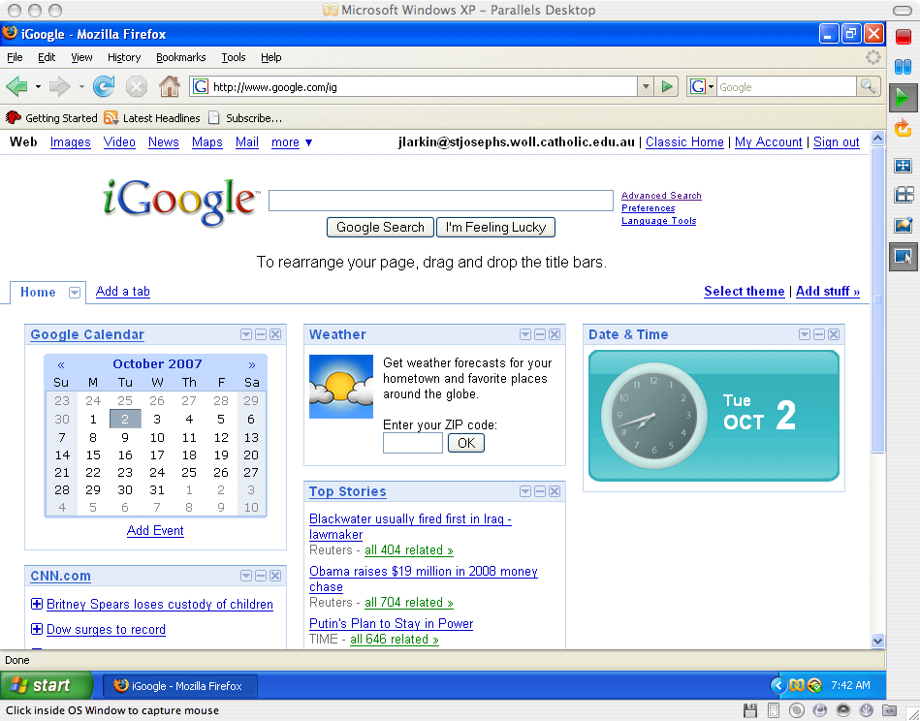

You can now customise this window by deleting unwanted elements or widgets. In order to add more elements or widgets click on the Add Stuff link on the right hand side of the window. The following window will appear.

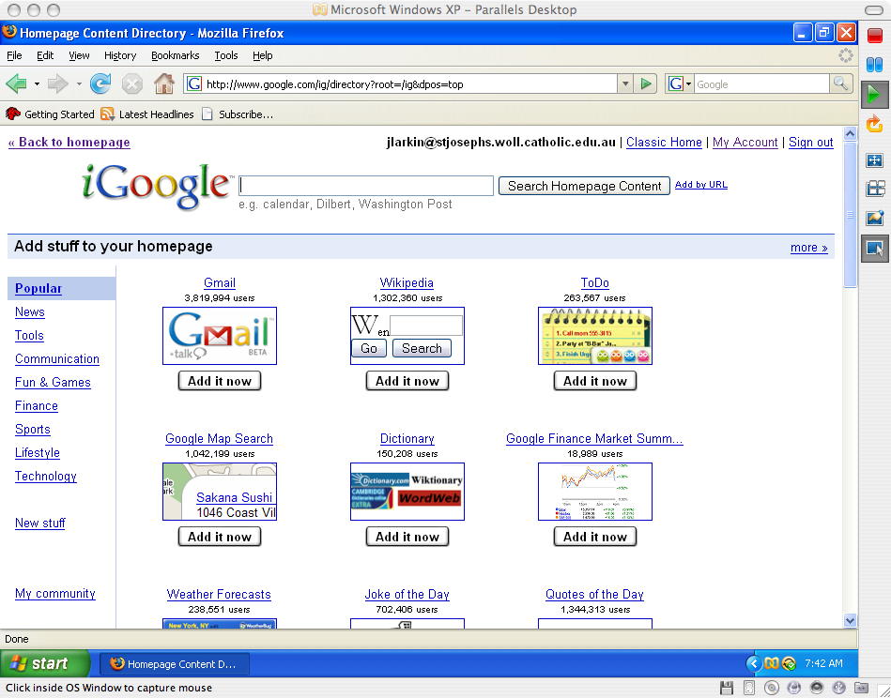

To easily add the Google Reader widget type in “Google Reader” in the search field and click on the Search Homepage Content button. The following window should appear.

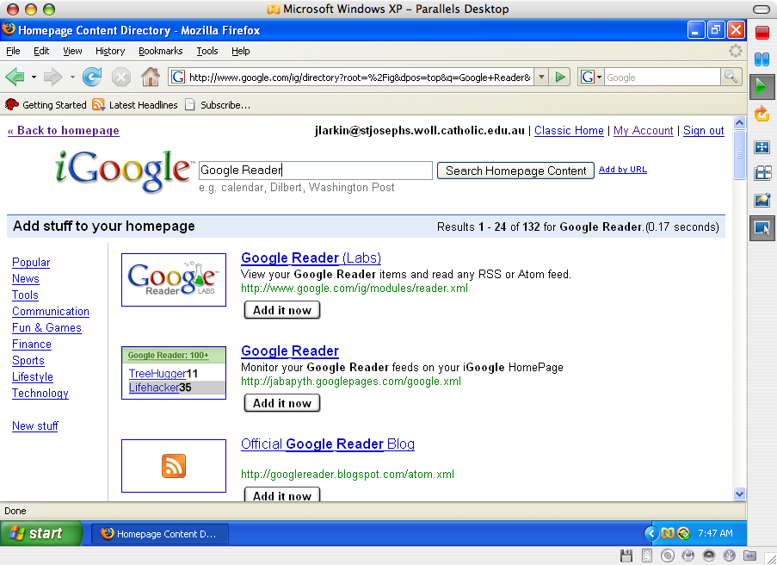

Click on the Add It Now button located beneath the Google Reader (Labs) widget. Then click on the Back to homepage link in the upper left corner of the window. The following window should appear.

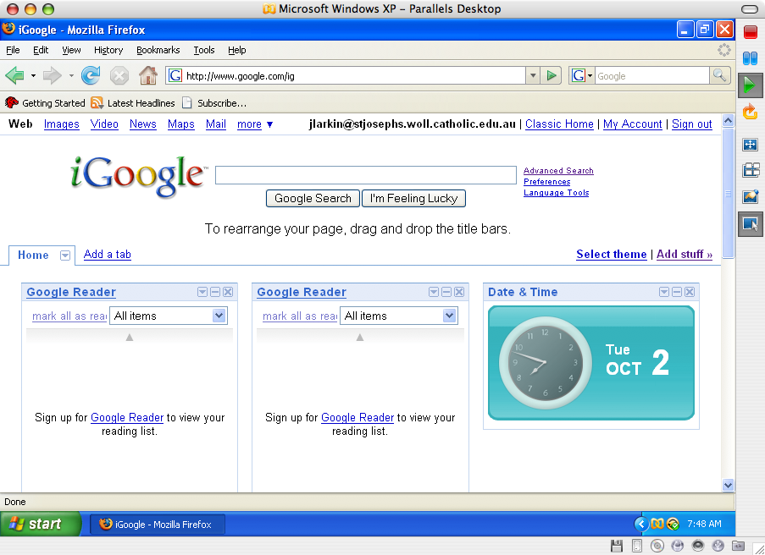

You will see that the Google Reader widget is now conveniently located on your iGoogle home page. This will be a very convenient method for you to keep tabs of your subscriptions.

