Setting up a Swicki

Why set up a “swicki”?

A swicki is new kind of search engine that allows anyone to create deep, focused searches on topics you care about. The interesting thing about swickis is that you create it and you can determine the focus area or subject matter of the search engine. This can benefit you and the research community with which you associate.

“This search engine, or swicki, can be published on your site. Your swicki presents search results that you're interested in, pulls in new relevant information as it is indexed, and organizes everything for you in a neat little customizable widget you can put on your web site or blog, complete with its very own buzz cloud that constantly updates to show you what are hot search terms in your community.” [http://swickihome.eurekster.com/faqs.htm]
Swickis allow you to specify the sources for your search and also to judge the results you obtain with this search. This can make your results more meaningful and useful. Great for students and teachers researching specific topics. You can embed your swicki on a web page or blog page. You can read more about why it is useful to set up an educational wiki by following these links:

Swicki FAQs

http://swickihome.eurekster.com/faqs.htm

Setting up a Swicki

For this exercise the Swicki software will be utilised. Open a web browser such as Internet Explorer and type this url in the address bar.

http://www.eurekster.com/ Your browser will take you to this page.

Click on the “Build a swicki” button to begin. You will need to complete a sign-up page and then the following window will appear

Choose a name for your Swicki and set a description

What is the subject focus of your Swicki? What is the main area of research? Think carefully on this. Brainstorm with your colleagues and students. This will assist with the development of an effective focus for the Swicki and its results. The following window allows you to set the name and description of the swicki.

Choose a name and indicate the topic in the first two fields.

The layout is important. You will embed your swicki in the right hand margin of your new blog. Select “Narrow Text Module”. You can choose the design for the swicki as well. Do you want a text or video swicki? I prefer vertical Text swickis.

Next, you will need to select relevant keywords for your Swicki.

What are the relevant keywords for your topic. Think of a range of keywords that you think are relevant for your subject matter. They can assist the Swicki engine to produce more relevant topic specific results.

Finally, on this page you will need to design the look and feel for your Swicki. You may like to ensure that the Swicki will match your web site’s design. You can choose whether to have an Advnaced or Basic design control panel on this page.

Advanced

Basic

Once you have completed the details on this page click on the Next button at the lower right hand corner of the web page.

Training your Swicki to think like you and your team

Remember to consider the subject focus of your Swicki. On this page you can list web sites that reflect the focus of your research

You can change the two topics that you entered on the previous page if you wish.

You can then decide what you want the Swicki to search. You would normally select the Web and RSS feeds. RSS feeds include blogs, for example.

A powerful aspect of this tool is the fact you can enter the address of web sites that you would like the Swicki to search.

You can also enter the address of web sites that wish to block from the Swicki search engine. This will train the Swicki to search more accurately for you.

Blocking advertisements

Your Swicki search results will have advertisements unless you block them. As you work for an educational institution I suggest that you check the box as shown in the graphic below.

That will indicate your status and you can opt out of advertisements. You will need to enter the name of your organization in the field that appears.

Click on the Next button when you have finished with the settings on this page. The following window will appear.

Swicki Description and Category

Write a brief description of your Swicki and choose some relevant subject categories. Note the Swicki URL. Click on the Next button when you have finished with the settings on this page. The following window will appear.
Adding your Swicki to your site or blog

This is the trickiest task you will perform. You need to take the html code for your new Swicki and paste it into your new blog? How? It is easy!

Select all of the code that appears in the “Copy the Buzzcloud code in the box below” window and select copy from the Edit menu.

You can then paste that code into the appropriate area of your blog template. Further instructions will be provided during the workshop.

You will notice that there are specific instructions for different types of blogs and web services. They include:
- Wordpress
- Blogger (new and old versions)
- Moveable Type
- TextPattern
- WidgetBox
- iGoogle
- TypePad
- NetVibes
- Piczo

Instructions for Wordpress and Blogger blogs are shown below.

Embedding the Swicki code into your new blog by copying and pasting the code.

If you are using Blogger you can copy and paste the code into a page element.

Once you have signed into your blog select the Templates tab and make sure that you have the Page Elements window visible. See below.

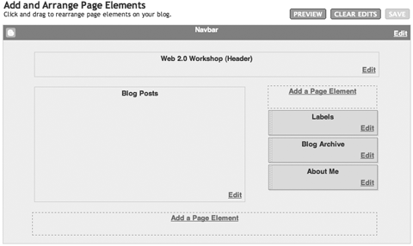
Click on the Add a Page Element link on the right hand side. The following window will appear.

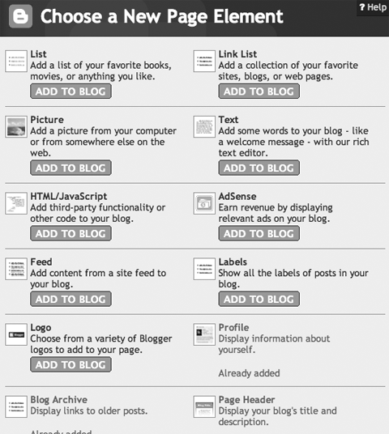

Click on the HTML/Javascript button that says “Add To Blog”. The following window will appear.

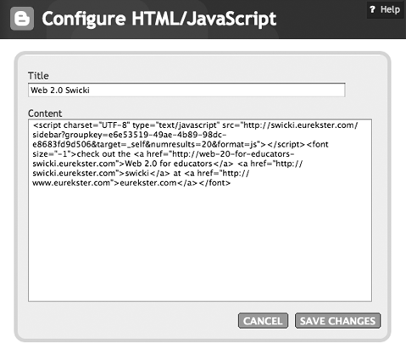

- Paste the code that you copied from Stage Three of the Swicki web site into this window as shown above.

- Type in a Title for the element.

- Click on the Save Changes button.

Note: Sometimes this process seems to last forever in Blogger. I recommend that you click back on the main Blogger window and click on the Settings Tab and then click on the Template tab. You will find that the new page element is present on the template page. See the example below.

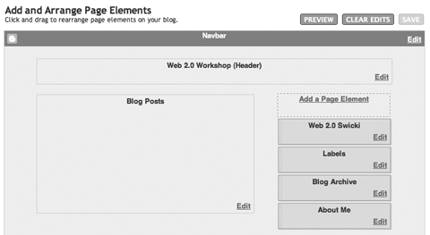

Try dragging the new Swicki element to the position that you prefer. This is a little tricky. Be patient. Refresh the page.

Click on the View Blog tab. You should see the new Swicki on the right hand side of your blog. See the example below.

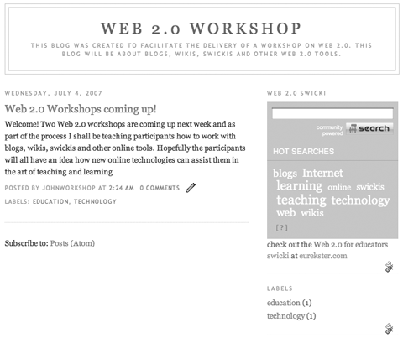 | That’s it! Try your Swicki and begin judging the results.

