Setting up a Jaiku feed on your blog

A key component of establishing social and learning networks is to allow your contacts to be aware of your work and research based activities. Your contacts can be alerted to your blog posts and you can also immediately post news and action items to the web. One method of achieving this is via Jaiku. It is quite easy to set up a Jaiku account and to place a Jaiku page on your blog or web page. You can use your Jaiku account to keep track of your contacts too.

Launch a web browser application such as Internet Explorer, Firefox or Safari. Type the following address in the web address field.
http://www.jaiku.com

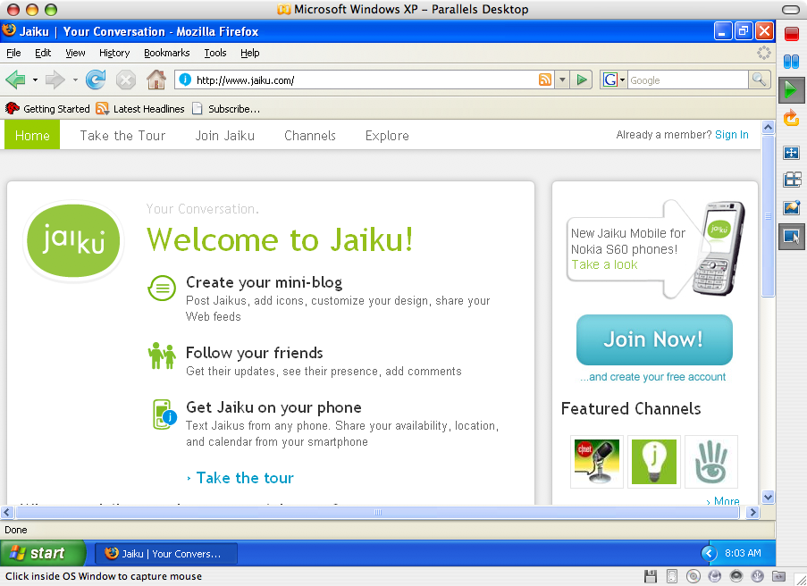

Click on the Join Now button located on the right hand side of the Jaiku window. The following window will appear.
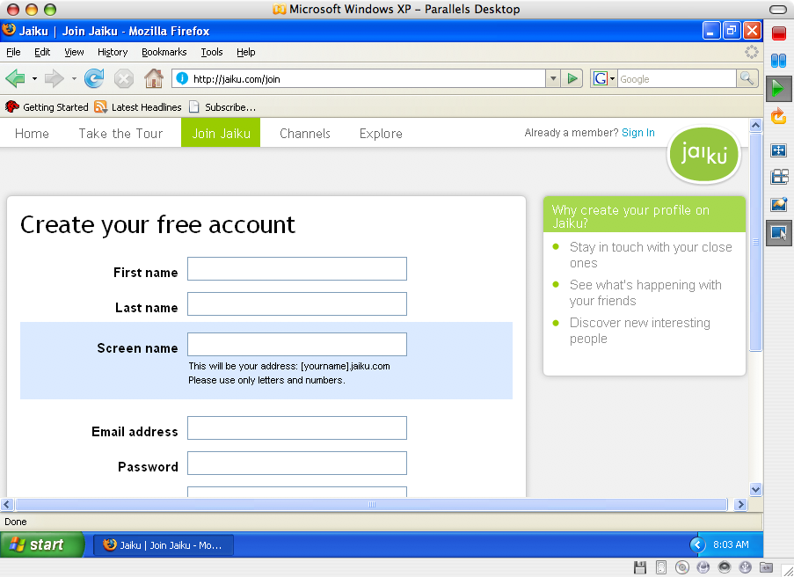

Follow the instructions and create an account. When you are finished click on the Home link upper left.

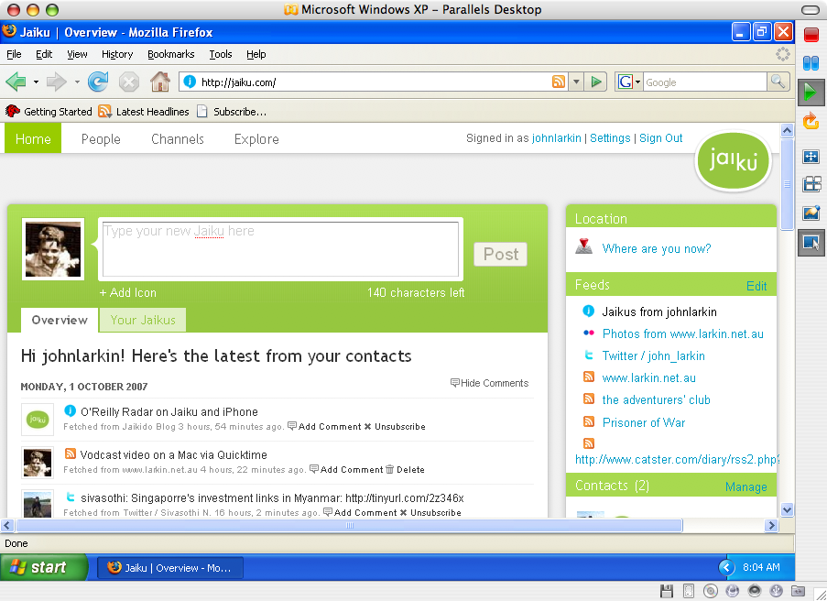

This is my Jaiku main page. As you can see I can directly enter news items in the field at the top of the screen. Beneath that my own feeds and those of other contacts are visible. On the right there is a list of blogs that I have connected to my Jaiku feed. Click on the Settings link at the top right of the Jaiku window. The window below will appear.

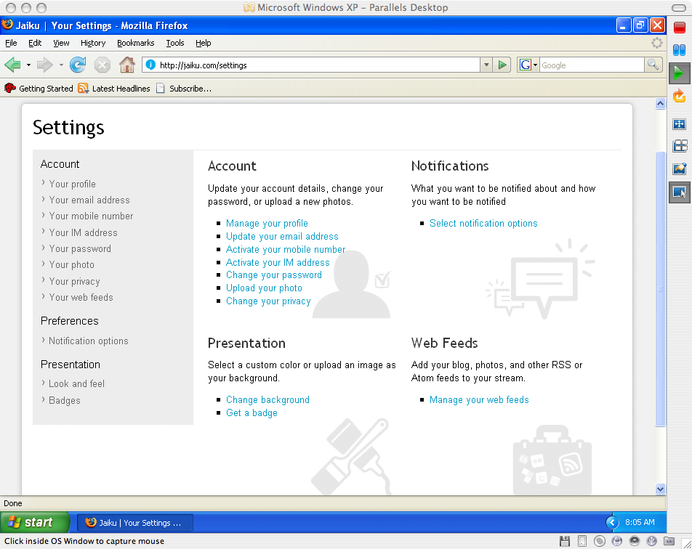

Take the time to explore all of the settings. They are self explanatory. We will focus on two for this workshop:

- Manage your web feeds
- Badges

Click on the Manage your web feeds link in the lower right hand corner of the Jaiku window. The following window will appear.
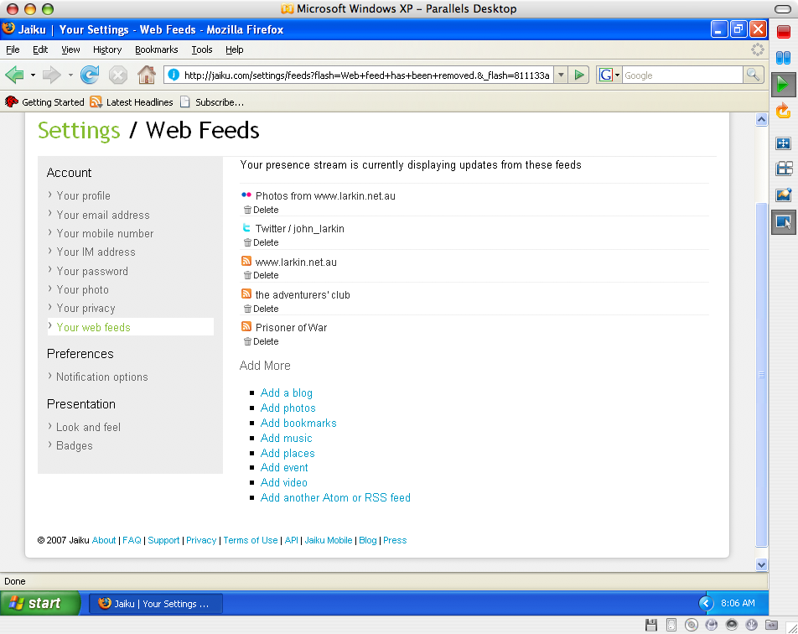

You may observe that I have linked five of my own “Web 2.0” sites to this Jaiku feed. I have linked three blogs, a Flickr account and a Twitter account. Each time I make a change to any of my blogs, Flickr or Twitter the update will appear in my Jaiku feed. Click on the Add a blog link to list your new blog in the Jaiku feed. The following window will appear.

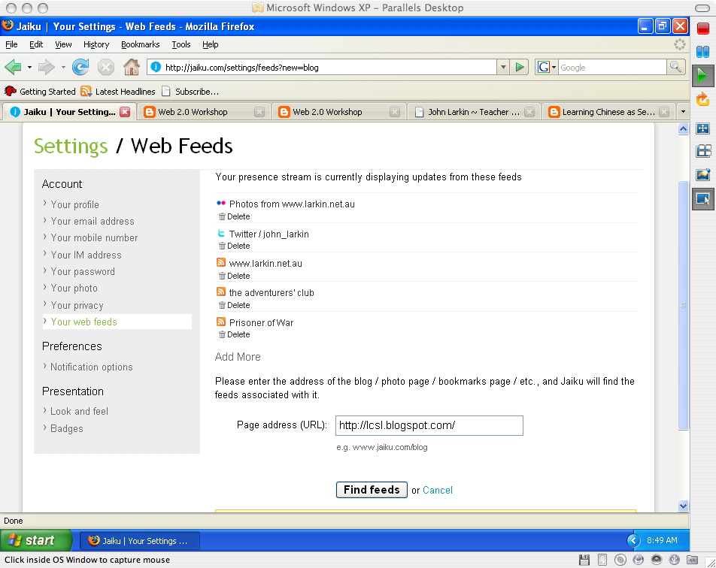

Type in the address of the blog as above and click on the Find feeds button. The following window will appear.

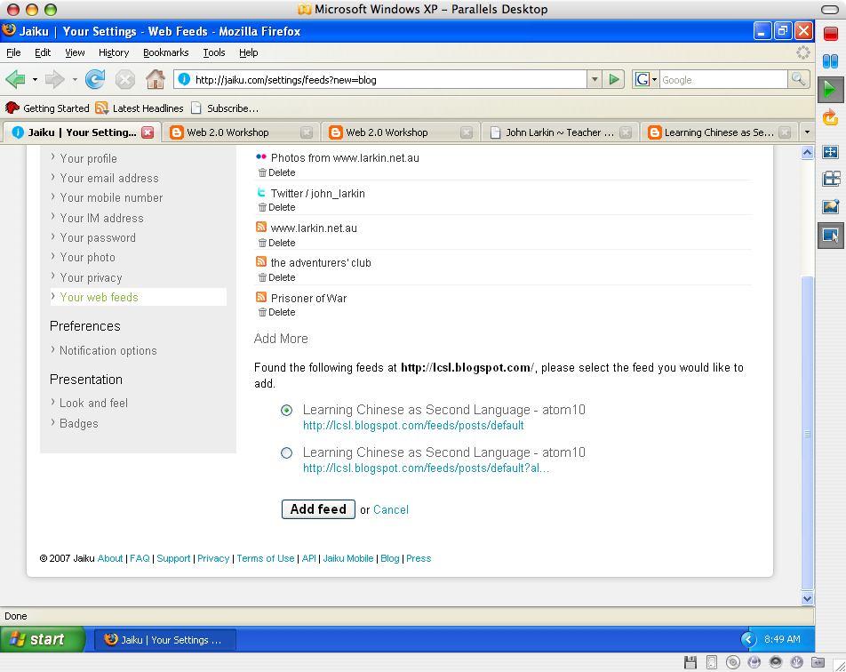

Jaiku has found the news feed for the blog and you can then click on the feed choice and then click on the Add feed button. The following window will appear after a moment.

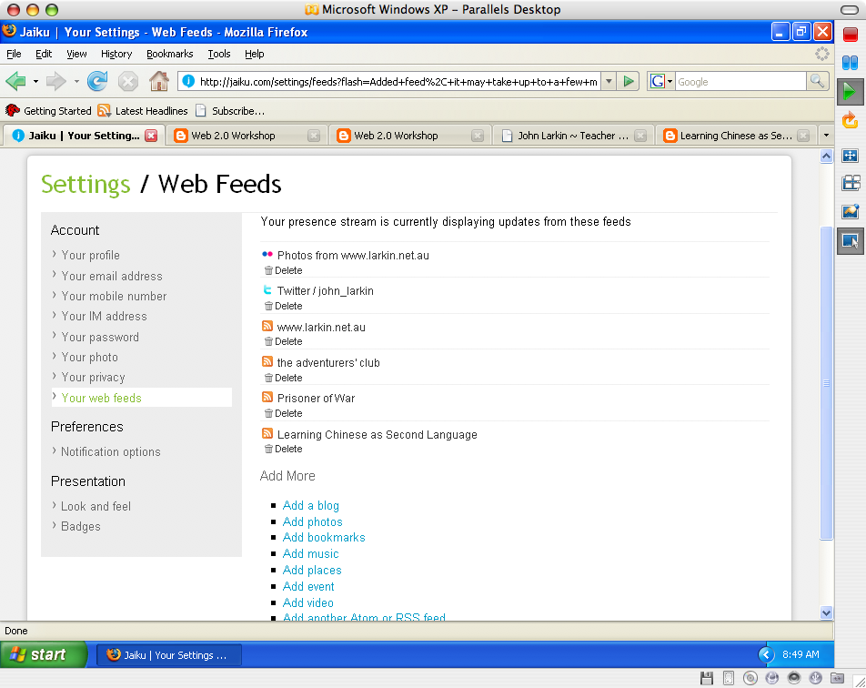

You will see that a new blog has been added to the feed. This blog belongs to my wife Shao Ping, actually.

Let’s set up a Jaiku badge on your blog. Click on the Badges link located on the lower left corner of the Settings page. The following window will appear.

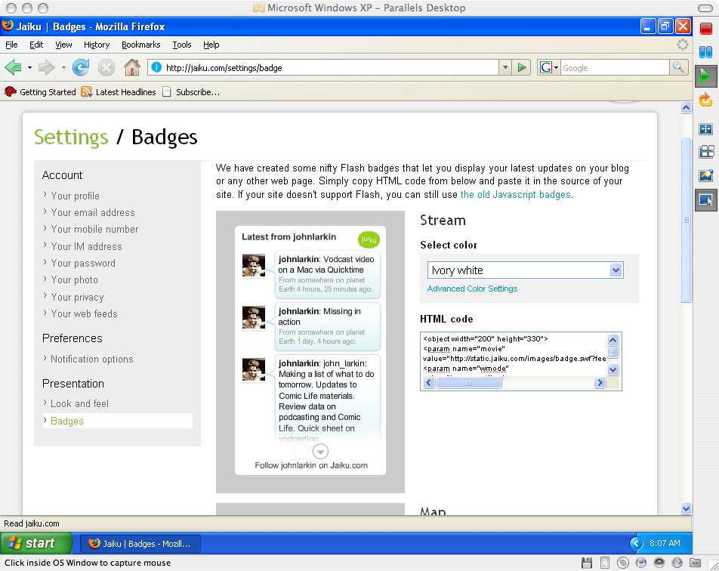

You can customise the appearance of the badge if you wish. Copy and paste the code in the HTML code window.

Open a new tab in your browser (File > New Tab) and point your browser to Google.

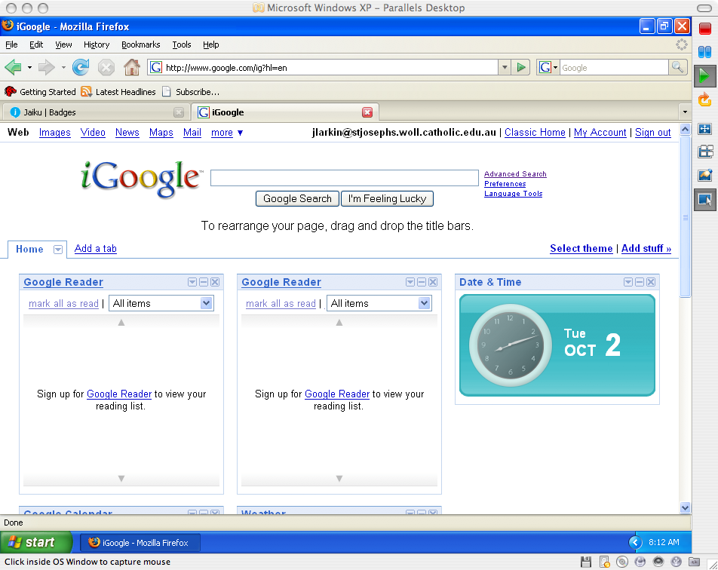

Log into your Google account if you have not already done so and the following window will appear.
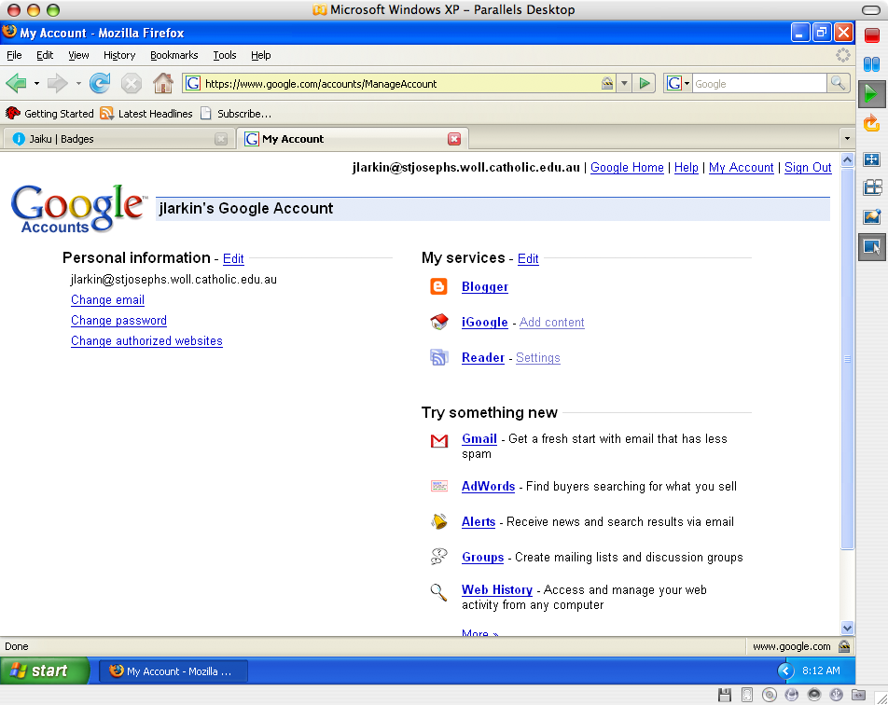

Click on the Blogger link and you will be taken to our Blogger Dashboard page. See below. [I have set up blogs for a number of my students]

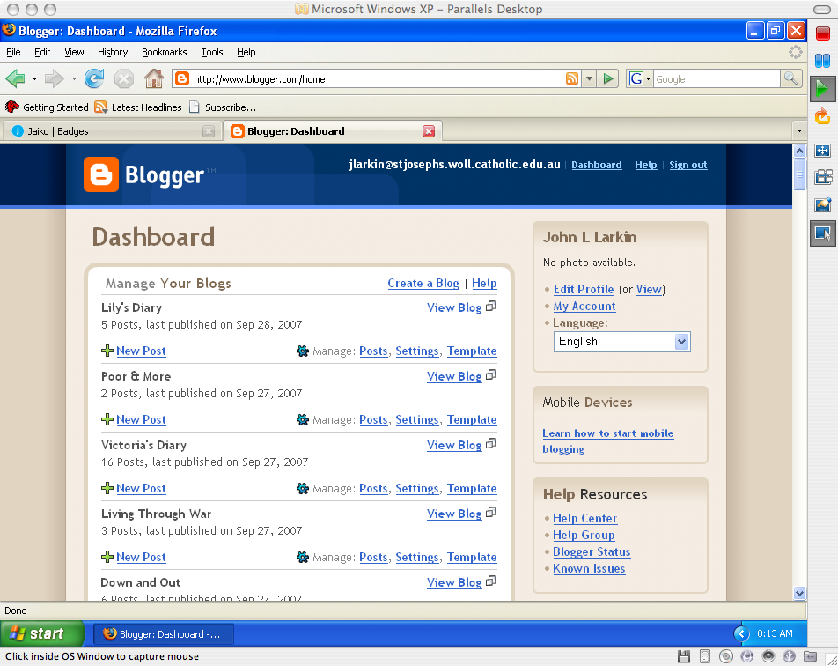

Click on the Layout link for your blog. The following window will appear.

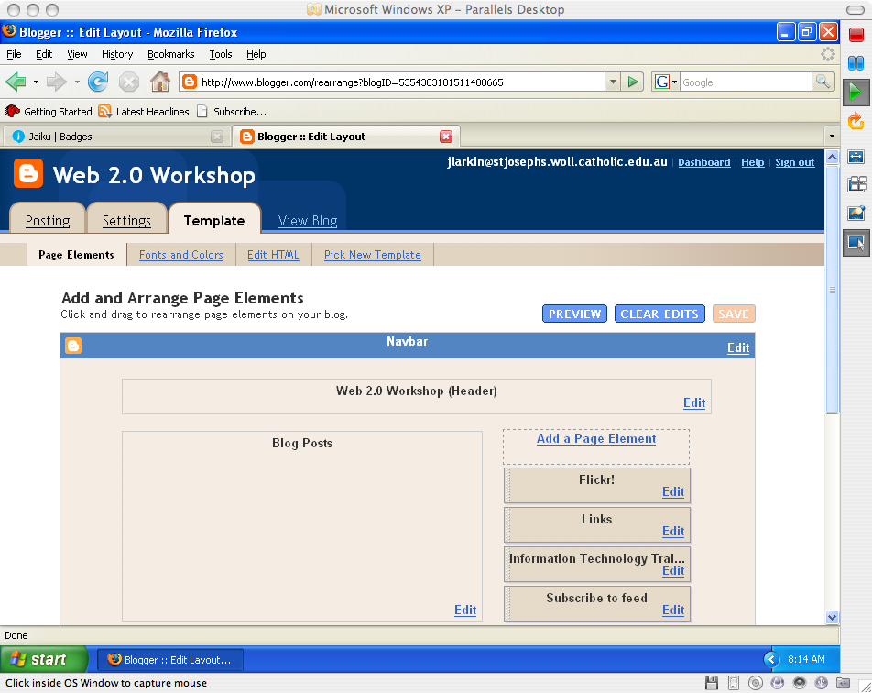

Click on the Add a Page Element link on the Layout page. In the example above it is located on the right. The following popup window will appear.

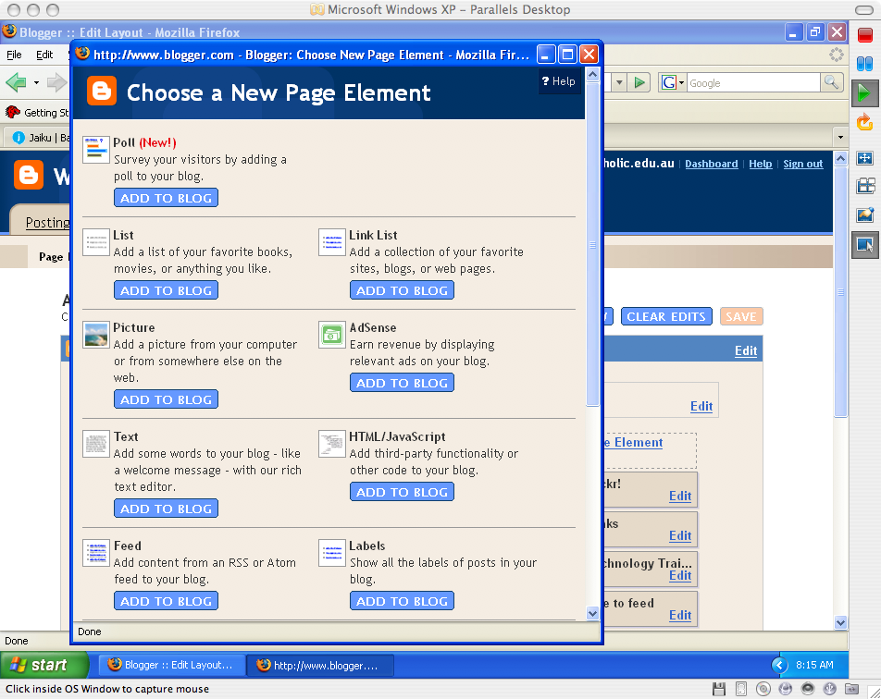

Locate the HTML/Javascript option and click on the Add To Blog button. The following popup window will appear.

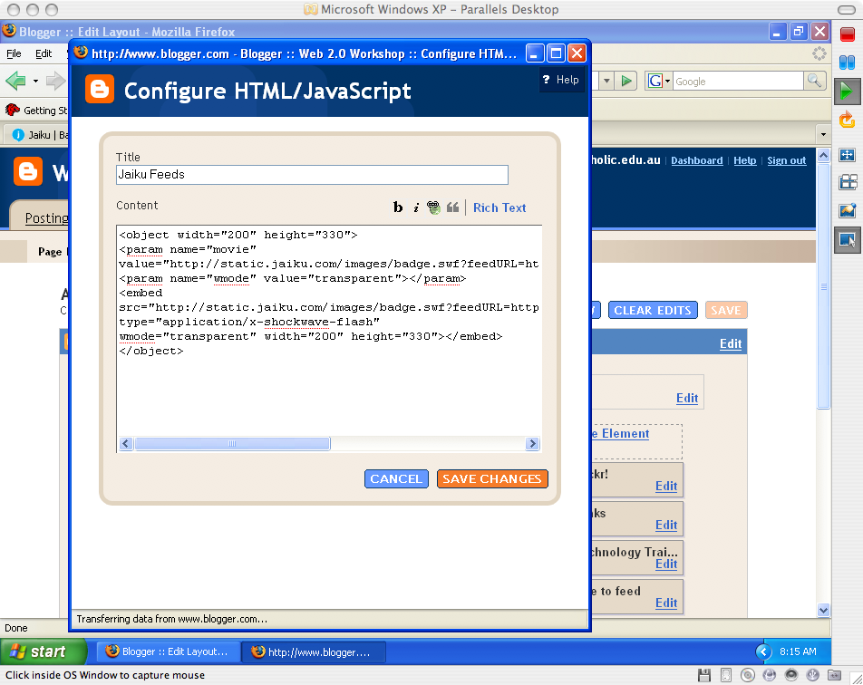

Paste the code from the Jaiku badge page to the Content field. Give a name to the content in the Title field. I typed Jaiku Feeds. Click on the Save Changes button. The following window will appear.

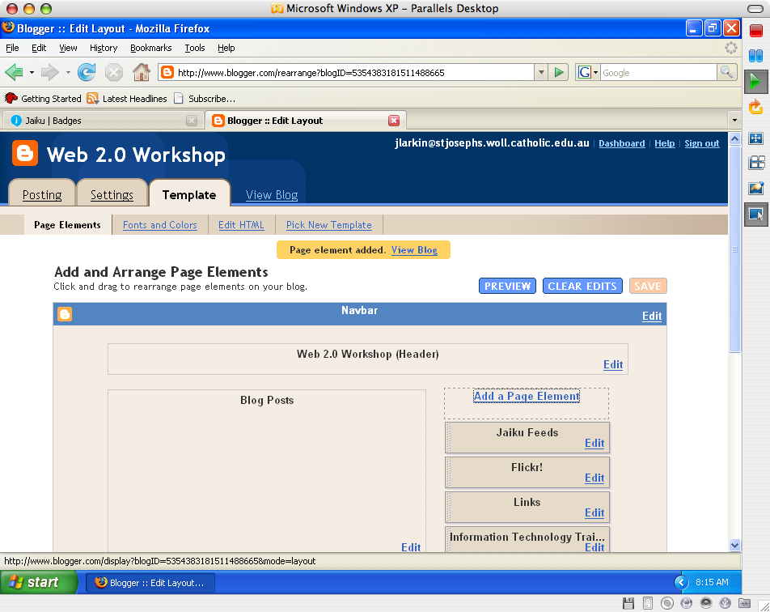

The page element has been added. Click on the View Blog link to see the updated blog page with the Jaiku badge. A window like that below will appear.

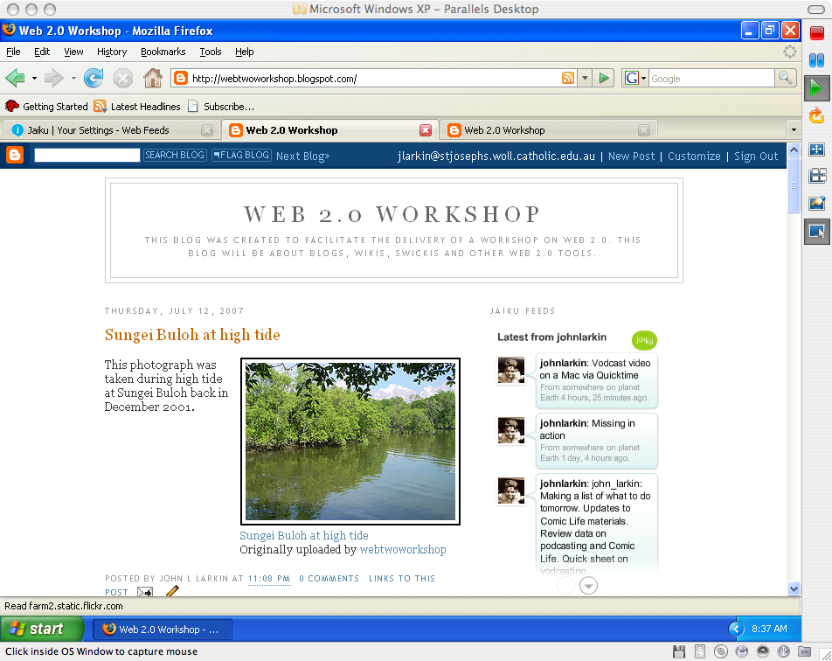

As you can see the Jaiku badge is visible in the margin on the right.

You should let your contacts know of your Jaiku home page address so that they can keep in touch with your news and activities. They can subscribe to your feed and you can subscribe to them in turn.

