Setting up a Delicious account

Setting up a Delicious account

Open a web browser such as Internet Explorer and type this url in the address bar.

http://delicious.com/ Your browser will take you to this page.

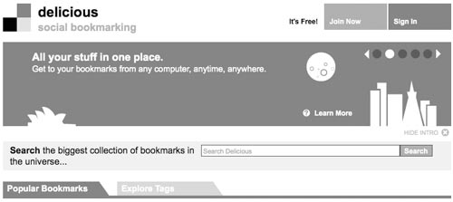

Click on the “Join Now” link in the upper right to begin. You will need to complete a sign-up page. See the window below.

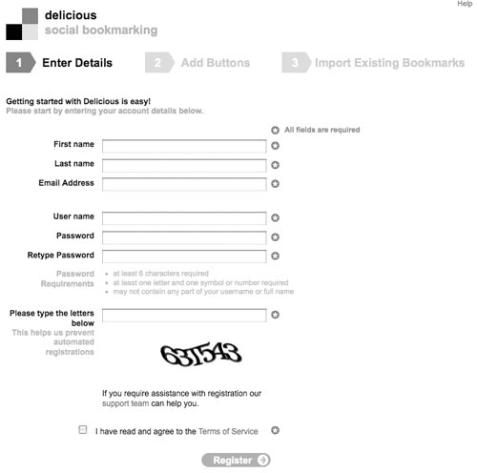

Complete the details and click on the Register button. You will be sent an email that will confirm your registration. Follow the instructions in the email. See below.

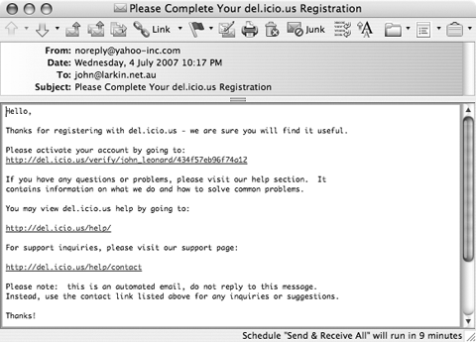

You will be directed to the following screen after you click on the link in the email. It will look something like this. The page may have been updated in recent weeks.

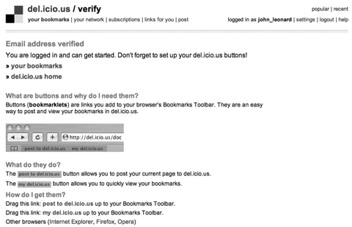

If you click on the “Your Bookmarks” link you will see that you have no entries. This is because you have not begun adding bookmarks to your “Delicious” account.

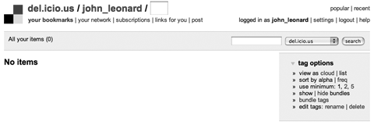

Adding bookmarks to your Delicious account

Go back to the following page and read the information about the importance of the buttons. Drag each of the two links (Post to Delicious and My Delicious) to the Bookmarks toolbar of your browser. The two links will appear as buttons on your browser bookmarks bar.

Each time you browse to a page that you wish to include in your Delicious bookmarks click on the Post to Delicious button on your browser’s bookmark bar and the following window will appear.

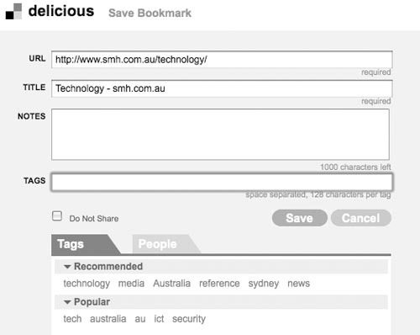

You can add some notes to the new bookmark as well as tags that will make it easier for you to categorise and locate your bookmarks later. Other users of Delicious bookmarks will find it easier to locate your bookmarks due to the tagging process as well. Suggested tags will be included in the window.

Complete the notes and add some tags to the bookmark. Once you have begun adding bookmarks your bookmarks page will look like the example below.

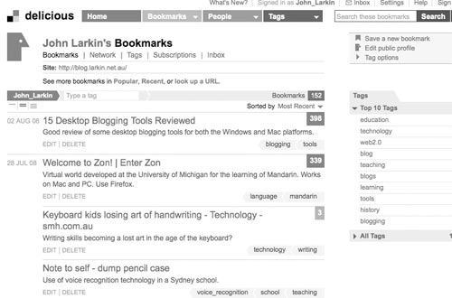
Alternative method for adding and tagging bookmarks

You can also use the Delicous bookmarking button son your browser if you installed it during the opening of your account.

If you have not added the buttons to your browser click on the Help link at the top of the page. The following page will appear:

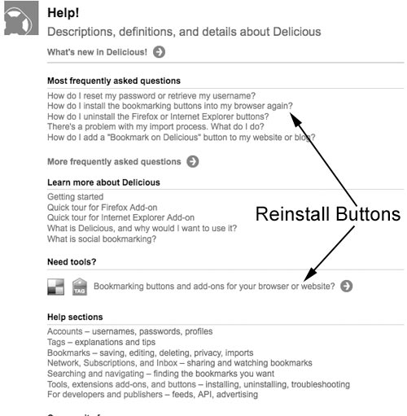

http://delicious.com/help

Click on either of the links indicated above:

- How do I install the bookmarking buttons into my browser again?
- Bookmarking buttons and add-ons for your browser or web site?

The following Tools page will appear.

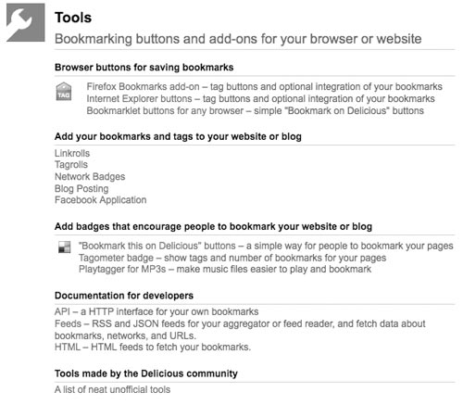

http://delicious.com/help/tools

Click on the link for the Browser buttons that you need, Firefox, Internet Explorer or another browser. The following windows will appear depending on your choice.

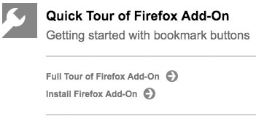

Installing Firefox buttons. Simply follow the instructions.

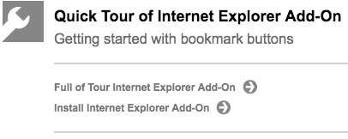

Installing Internet Explorer buttons. Simply follow the instructions.

Adding Delicious links to your blog

You can add a dynamic list of your bookmarks to your blog’s sidebar. The list will feature your most recently added bookmarks. You will need to copy and paste some data from the Delicious Tools page to your blog.

http://delicious.com/help/tools
Go to the Delicous Tools page and click on the link, Linkrolls. The following page will appear.

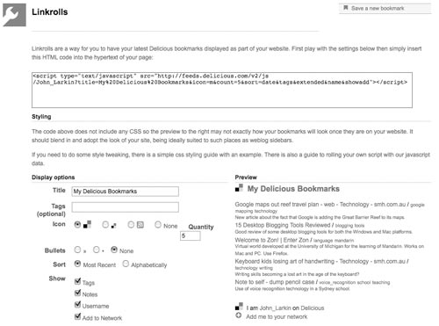

Complete the details and make your selections. A preview will appear on the righrt hand side of the page. When you have finished select and copy all of the code in the field above. Now, to add the code to your blog.

Adding the Delicious code to your blog.

You will now need to open your blog that you created today. Open your new blog on a new browser page. Once you have signed into your blog select the Layouts link or tab and make sure that you have the Page Elements window visible. See below.

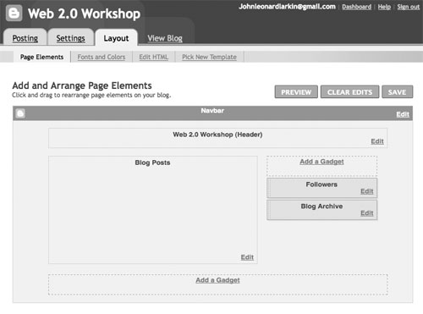

Click on the Add a Gadget link on the right. The following window will appear.

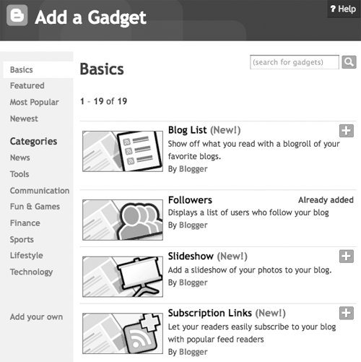

Scroll down the Basic gadgets list until your reach the following Gadget: HTML/Javascript

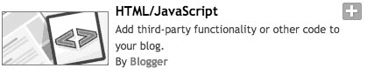

Click on the Gadget icon or the plus button to open the gadget. The following window will appear.

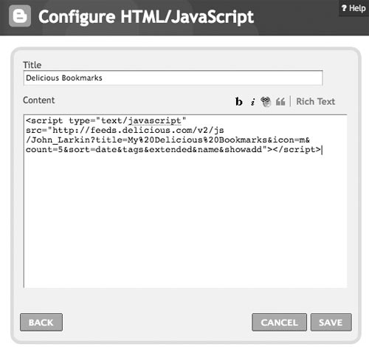

- Paste the code that you copied from the Delicious Linkrolls page into this window as shown above.

- Type in a Title for the gadget.

- Click on the Save button.

Note: Sometimes this process seems to last forever. This is a bug in Blogger although it seems to have been resolved recently.

If there does seem to be a problem I recommend that you click back on the main Blogger window and click on the Settings Tab and then click on the Template tab. You will find that the new gadget is present on the template page. See the example below.

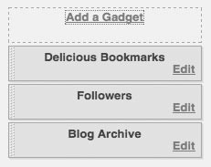

You can see that the Delicious Bookmarks gadget has been added.

Arrange the page elements to meet your needs. Click on the View Blog tab and you should see the Delicious Linkroll as below.

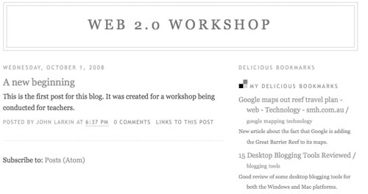

Delicious as a Search engine ~ a most powerful feature

Please note that you can search the Delicious site as you would Google. You will locate frequently bookmarked sites and other users. You can subscribe to the bookmarks of other users in your RSS feed reader.

