Setting up a Twitter and adding a Twitter feed to your blog

A key component of establishing social and learning networks is to allow your contacts to be aware of your work and research based activities. Your contacts can be alerted to your activities and you can also immediately post news and action items to the web. One method of achieving this is via Twitter. It is quite easy to set up a Twitter account and to place a Twitter badge on your blog or web page. You can use your Twitter account to keep track of your contacts as well.

Launch a web browser application such as Internet Explorer, Firefox or Safari. Type the following address in the web address field.
http://www.twitter.com/



Click on the Get Started - Join link located on the Twitter window. The following window will appear.

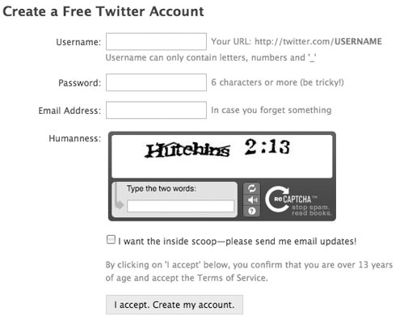

Follow the instructions and create an account. When you are finished click on the Twitter name or Home link.

This is my Twitter main page. As you can see I can directly enter news items in the field at the top of the screen. Beneath that my own feeds and those of other contacts are visible

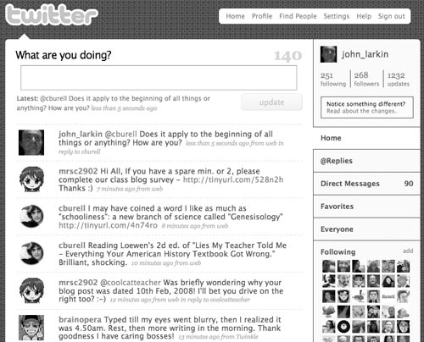

. Click on the Settings link at the top right of the Twitter window. The window below will appear.

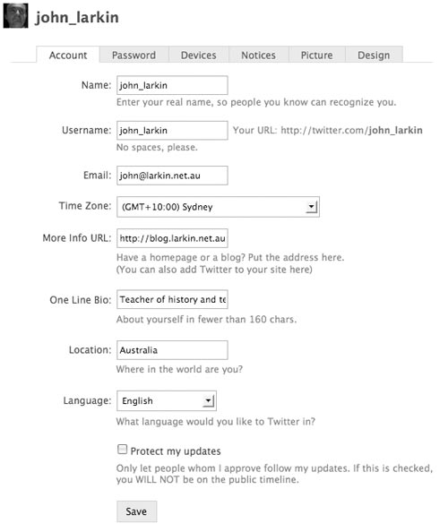

Take the time to explore all of the settings. They are self explanatory. We will focus on one for this workshop:

Badges

Let’s set up a Twitter badge on your blog. Type in the following url on yoru browser after you have logged into Twitter.

http://twitter.com/badges

The following page will appear. Choose the option that best suits your need. I shall select other for my Wordpress blog. If you are working with Blogger you will select Blogger of course.

If it is a Blogger blog. The following page will appear.

Set the number of updates for your Twitter badge. I have set mine to 1 update. Click on the Insert into your Blog button located on the left. The following window will appear if you are currently signed into your Google account. Otherwise you will simply need to sign in.

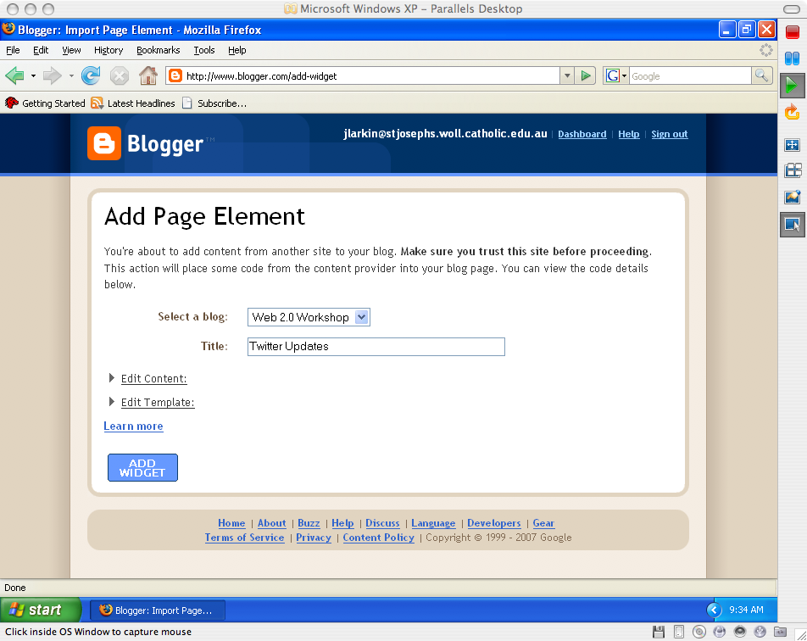

Select a Blog from the drop down menu and give it a Title, as above. Click on the Add Widget button. The following gadget will appear on your blog’s page elements page. | 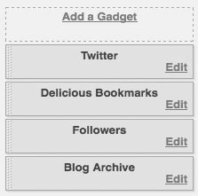
The Twitter badge or widget has automatically been added. You can drag it to a new position among the page elements if you wish. Click on the View Blog link at the top of the window. The following window will appear.  As you can see the Twitter badge is visible in the margin on the right. | 

You should let your contacts know of your Twitter home page address so that they can keep in touch with your news and activities. They can subscribe to your feed and you can subscribe to them in turn.

Blocking followers

You can remove a follower from your page (and yourself from theirs) without protecting your updates and approving each and every friend request. Here's how:

1. Log in to Twitter.
2. Go to the profile page of the person you wish to block.
3. Click Block (at bottom right, in the sidebar.)
4. Click OKAY to confirm the block

When you completed these steps you will not appear on the blocked person’s profile page, friends time line, badge, or anywhere else. The person will not be notified that they've been blocked, and they will not be able to add you as friend.

Getting more out of Twitter

There are some tools and web sites that can help you get a lot more out of Twitter. Some of the best are listed below. There is a complete list at the Twitter Fan WIki: http://twitter.pbwiki.com/Apps

Twhirl  This is an excellent software tool that allows you to keep up with Twitter without logging into a Twitter via a browser. | 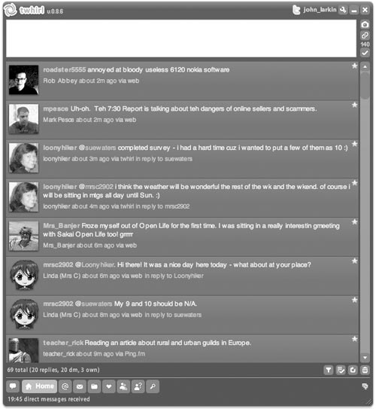
Twitterific is an excellent Macintosh application that will enable you to monitor and update Twitter.

http://iconfactory.com/software/twitterrific

Snitter is a neat app that works on both PCs and Macs. You can use it to monitor and update Twitter.

http://snook.ca/snitter/

Tweetbar is a plug-in for the Firefox and Flock browsers.

http://mikedemers.net/projects/tweetbar/

Twiity Tunes is a plug-in for the Firefox and Flock browsers.

https://addons.mozilla.org/en-US/firefox/addon/4994

Tweetscan is a real time search for Twitter posts

http://tweetscan.com/

