Setting up Feedburner

Setting up a Feedburner account

Open a web browser such as Internet Explorer and type this url in the address bar.

http://www.feedburner.com/ Your browser will take you to this page.

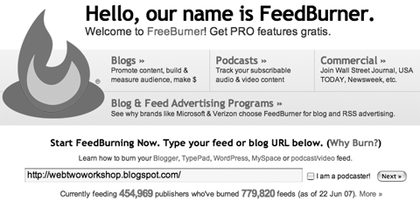

Enter the web site address of your blog and click on the Next button. You will be taken to this page.

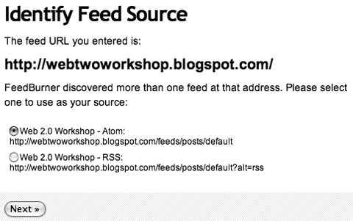

Click on either of the two feed links and click on the Next button. You will be taken to this page.

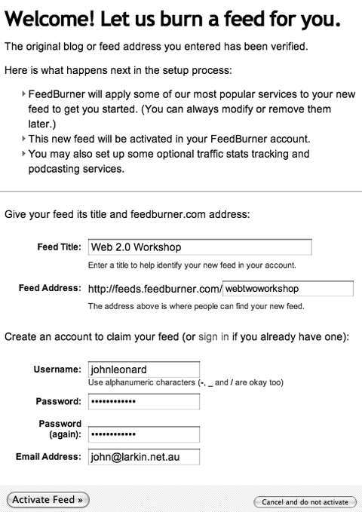

Complete your details and click on the Activate Feed button. You will be taken to this page.

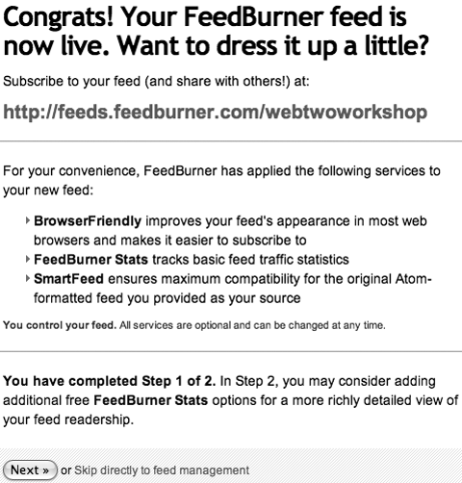

Do not make any changes. Click on the Next button. You will be taken to this page.

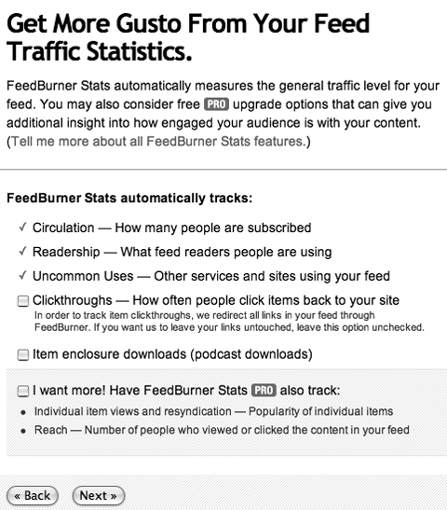

Do not make any changes. Click on the Next button. You will be taken to this page.

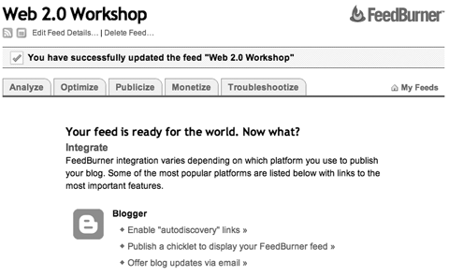

Click on the Publicize tab at the top of the window. You will be taken to this page.

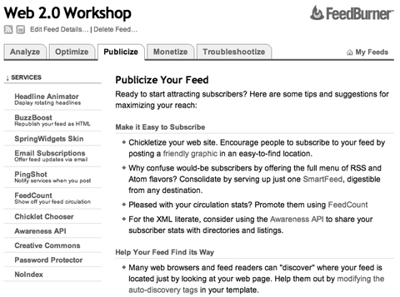

Click on Chicklet Chooser in the column on the left. You will be taken to this page.

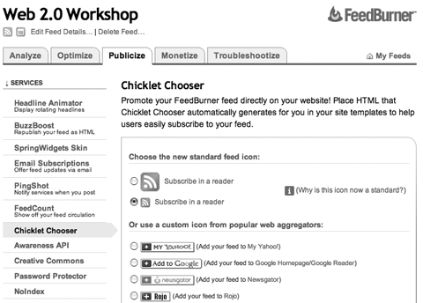

Select the small standard feed icon from the list of icons. See the example in the window above.

Scroll to the bottom of the page and select Blogger from the menu at the bottom of the page. See the example below.

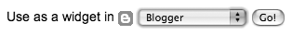

Click on the Go button. You will be taken to Blogger and you may have to sign in.

The following window will appear:

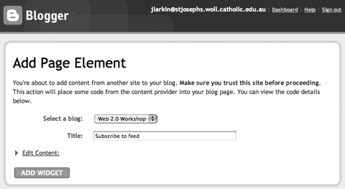

Select your blog from the popup menu, as above, and enter a title for the element. Click on the Add Widget button.

Note: Sometimes this process seems to last forever. I recommend that you click back on the main Blogger window and click on the Settings Tab and then click on the Template tab. You will find that the new page element is present on the template page. See the example below.

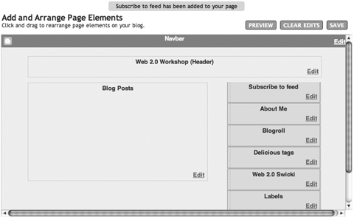

Click on the View Blog tab and you should see the Feedburner link as below.

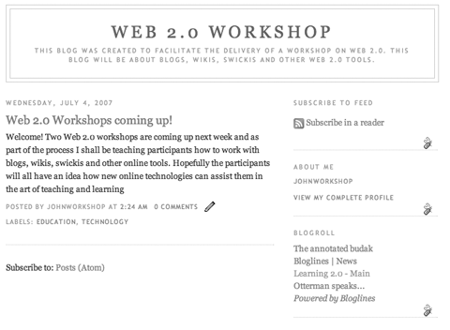

That’s it!

