Setting up Flickr

Flickr is a photo sharing tool that has rich functionality and allows the public to share their photographs with others., It allows educators to publish photographs of research materials, field trips and educational gatherings. Its photo tagging and annotation features also allows teachers to test the knowledge of students on specific topics. It is an excellent component of the Web 2.0 suite of tools.

Setting up a Flickr account

Open a web browser such as Internet Explorer and type this url in the address bar.

http://flickr.com/ Your browser will take you to this page.

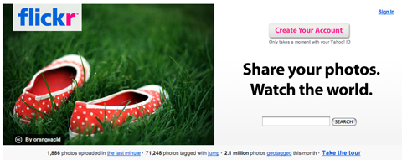

Click on the Create Your Account button. You will be taken to this screen.

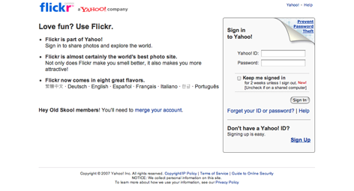

If you already have a Yahoo account then simply sign in otherwise click on Sign Up in the bottom right hand corner and create a Yahoo account. When you sign up you will see this screen.
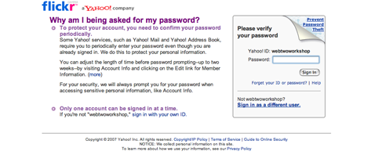

Sign in with your Yahoo ID. You will be taken to this screen.

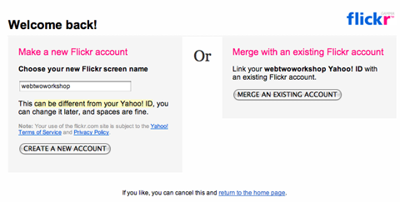

Click on Create A New Account. You will be taken to this screen.

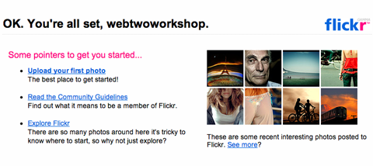

Click on Upload your first photo. You will be taken to this screen.

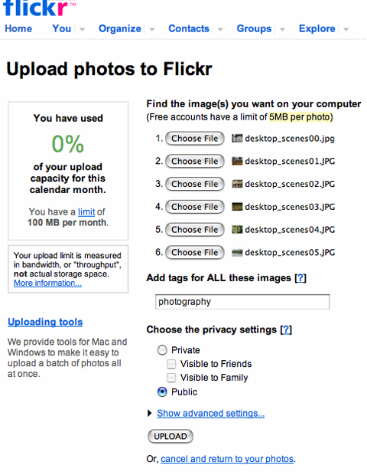

Once you have browsed to the photographs and selected them for upload decide whether they will be private or public and then click Upload. You will be taken to this screen.

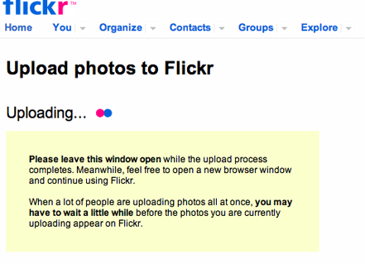

When the photographs have uploaded they will appear on the following screen.

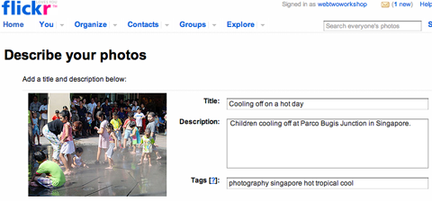

Add a title, description and tag to each photograph and then click Save. You will be taken to this screen.

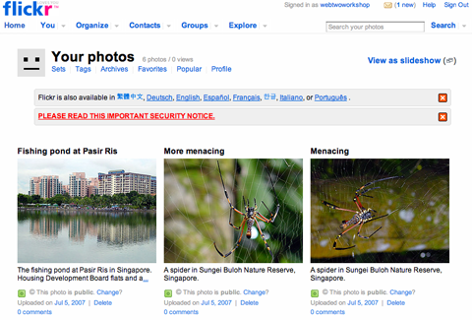

You can now organise your photographs by creating sets for example. Click on Sets to organise the photographs. You will be taken to this screen.

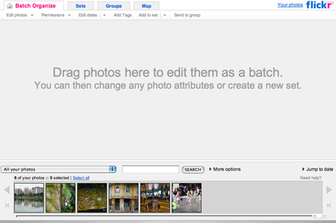

Follow the instructions on screen. Once you have finished the sets will be listed on your Flickr page.

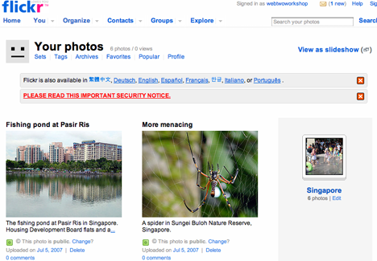

Click one of your photographs. Look closely at the example below. You will notice that each photograph has a range of buttons situated above.

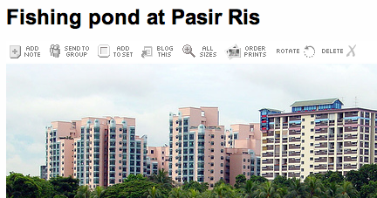

Add Note:  Send To Group:  Add To Set:  Blog This:  All Sizes:  Order Prints:  Rotate:  Delete: | Great for annotating parts of a photograph.  Forward the photograph to a specific group of people.  Add the photograph to a set.  Add the photograph to your blog.  View the various sizes of images.  Order copies of the image.  Rotate the image.  Remove the image.

Click on the Blog This button. You will see the following screen.

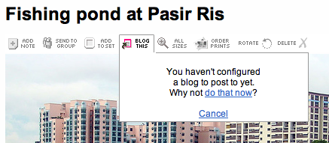

Click on “do that know”. You will see the following screen.

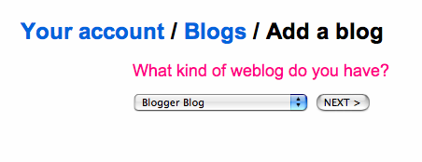

Click on Next. You will see the following screen.

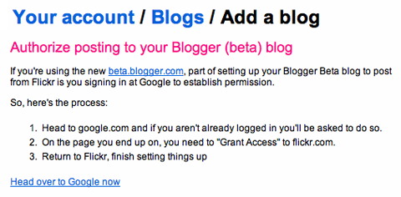
Click on Head over to Google now. You will see the following screen.

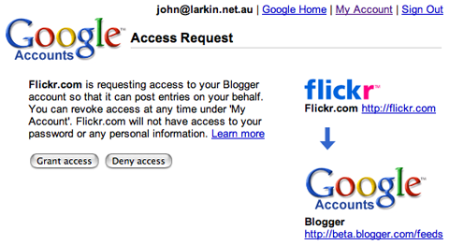

Click on Grant access now. You will see the following screen.

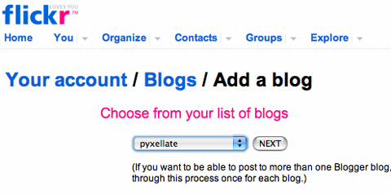

Select your new blog. Click on Next. You will see the following screen.

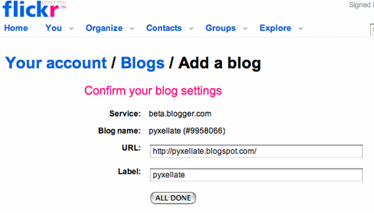

Click on All Done after checking the details. You will see the following screen.

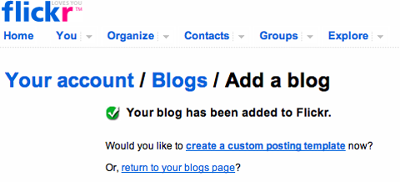

Click on Create a custon posting template. You will see the following screen.
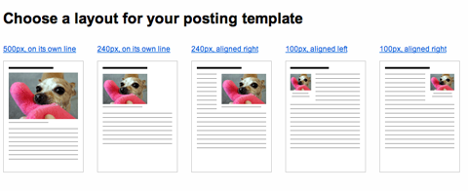

Click on one of the five layouts. You will see the following screen.

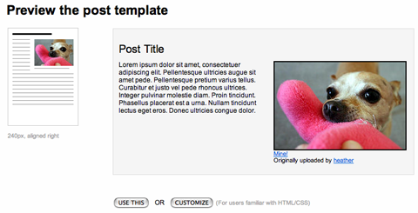

Click on Use This. You will see the following screen.
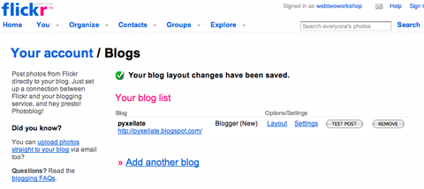

Flickr Uploader.

A great tool is available to upload multiple images to Flickr from your PC. It is called Flikr Uploader. You can download this tool from the following page.

http://flickr.com/tools/

