Cities

Why do people live in cities?
What can the past teach us about the present?

An Integrated Teaching and Learning Unit

Overview

Cities around the world are growing in terms of their population and global influence. Some cities have coped well with these changes. Some cities have failed to cope with change. Cities are transforming the land and transforming our lives.

The transition from a world where the majority of the population live in rural areas to one where the majority live in cities has caused many issues associated with urbanisation that the people of the world need to address.

Can we learn from the past? Ancient Rome too was a great city that grew in term of its population and regional influence. Are the problems faced by cities today a reflection of the issues experienced in the city of ancient Rome?

Enduring Understanding

Students should evolve an awareness that unless the people of this world maintain the wellbeing of the cities in which they live there may come a time when the cities, and the planet itself, may become uninhabitable.

Teaching and Learning Areas

History ~ Geography ~ Technology and Applied Science

Your challenge

You are a city planner. Your job is to look closely at a modern city and understand how it functions. You are to keep a diary of your day to day work as you attempt to solve the problems of urbanisation in that city. When you go home each day you spend some time on your hobby which is the study of ancient cities. Your also record your discoveries and ideas regarding the ancient city in your diary on a day to day basis, noting similarities, differences and interesting anecdotes as your proceed.

Work related observations  - The people ~ rich and poor  - The layout and land use of the city  - Urban sprawl  - Transport  - Resource use  - Water use  - Problems  - Buildings | Personal observations  - Government  - Poverty  - Injustice  - Lifestyle  - Wealth  - Entertainments  - Arts and culture  - Music  - Writing  - Religion
Modern City  - New York  - Mumbai  - Mexico City  - Tokyo  - London  - Shanghai  - Sao Paolo | Ancient City  - Rome  [Undecided….]  - Athens, Greece  - Memphis, Egypt
Your diary can include words, pictures, sketches, audio and video. Your final diary entry should provide a report on the steps that you would take to improve the condition of the lives of the people in the modern city that you examined.
Syllabus References
Note: Taken from the Stage 4 History Syllabus of New South Wales Board of Studies

History

Topic 2 Societies and Civilisations of the Past

This topic provides opportunities for breadth and depth in the study of History in Stage 4. Students can investigate ancient, medieval and early modern societies from both European and non-European perspectives, while acquiring basic skills of historical inquiry and communication.

Inquiry questions

- What can we learn about societies and civilisations of the past?
- What have been the legacies of past societies and civilisations?

Outcomes

Throughout this topic, students work towards all outcomes, with particular focus on those listed below.

A student:

4.1 describes and explains the nature of history, the main features of past societies and periods and their legacy
4.5 identifies the meaning, purpose and context of historical sources
4.8 locates, selects and organises relevant information from a number of sources, including ICT, to conduct basic historical research
4.10 selects and uses appropriate oral, written and other forms, including ICT, to communicate effectively about the past.

Working Historically  Historical skills to be integrated into this topic:  - sequence events within specific periods of time  - use historical terms and concepts in appropriate contexts  - identify different types of sources relevant to the study  - draw conclusions about the usefulness of sources for an historical inquiry  - locate, select and organise information from a range of sources.  ICT skills appropriate for this topic may include:  - locate, select and organise information from a range of sources, including a website  - use an image bank to gather relevant images for an historical inquiry  - communicate effectively about the past through a desktop published document.  Suggested Site Studies include:  - a museum visit  - an archaeological site  - a virtual site or an archaeological/museum site. |  | Students learn about:  - the origins of the society or period  - daily life of men and women in the society or period  - civics and citizenship in the society or period  - rights and freedoms  Students learn to:  - identify the origins of the society or historical period  - describe how both men and women lived in the society or period  - describe the way in which the people of the society or period were governed  - describe the rights and freedoms of different groups in the society or period  explain the beliefs and values of the society  - explain the impact made by significant people and/or events on the society or period  - outline the contacts that the society had with other peoples  - assess the legacy of the society or period for our world cultural heritage

Geography
Note: Taken from the Stage 4 Geography Syllabus of New South Wales Board of Studies

Focus Area 4G4 Global Issues and the Role of Citizenship

Focus: Global geographical issues and appropriate methods of citizenship for their management.

Outcomes
A student:

4.2 organises and interprets geographical information
4.3 uses a range of written, oral and graphic forms to communicate geographical information
4.4 uses a range of geographical tools
4.7 identifies and discusses geographical issues from a range of perspectives
4.8 describes the interrelationships between people and environments
4.9 describes differences in life opportunities throughout the world
4.10 explains how geographical knowledge, understanding and skills combine with knowledge of civics to contribute to informed citizenship.

Geographical tools in this focus area

The geographical tools listed below are to be integrated into teaching and learning activities in this focus area.

Maps  - use an atlas  - use various types of maps: physical, political, topographic, thematic  - locate features on a map using latitude and longitude, area and grid references  - use the points of a compass to determine direction  - construct a sketch map |  | Fieldwork  - use geographical instruments  - collect and record data in the field  Graphs and Statistics  - identify and calculate maximum, total, range, rank, and average  - construct and interpret bar column, line, climatic and proportional graphs  Photographs  - draw a line drawing  - collect and interpret photographic images

The following ICT are suggested for integration in teaching and learning in 4G4:

- use a range of digital images, maps, sound and other appropriate multimedia sources to develop a multimedia presentation or webpage

Students learn about:  Global geographical issues  - Global geographical issues: urbanisation  - The need to promote ecological sustainability  Perspective  - the nature of the issue  - different perspectives relevant to the issue  - the responsibility of governments to the issue  - the actions of individuals, groups and governments  - implications for social justice and equity |  | Students learn to:  - recognise global geographical issues  - describe the nature of global geographical issues  - explain the links between human actions and the consequences for ecological sustainability on a global scale  - describe the spatial dimensions of the issue  - describe the ecological dimensions of the issue  - identify perspectives and bias about the issue, including in media reports  - describe the actions of individuals, groups and governments in relation to the issue  - communicate appropriately with organisations to participate as a global citizen

Technology and Applied Science

Note: Taken from the Stage 4 Technology and Applied Science Syllabus of New South Wales Board of Studies

Industrial Technology – Multimedia/Photography

The Multimedia/Photography focus area provides opportunities for students to develop knowledge, understanding and skills in relation to multimedia, photographic and associated industries.

Core modules develop knowledge and skills in the use of materials, tools and techniques related to multimedia or photography which are enhanced and further developed through the study of specialist modules in photographic or multimedia-based technologies.

Practical projects should reflect the nature of the Multimedia/Photography focus area and provide opportunities for students to develop specific knowledge, understanding and skills related to multimedia and/or photography-related technologies. These may include:

- individual photographic images
- photographic presentations
- brochures incorporating photographic images
- photo journals
- computer animations
- webpages.

Projects should promote the sequential development of skills and reflect an increasing degree of student autonomy as they progress through the course.

Industrial Technology – Multimedia/Photography
Multimedia – Core Module 1
Students learn about: | Students learn to:
Design
- desktop publishing principles for print and electronic distribution such as:  - typography/font styles  - white space and colour choices  - Gutenberg Diagram (Primary Optical Area/Terminal Anchor)  - design principles and processes used in multimedia presentations  - storyboarding used in the multimedia industry for planning a range of presentations | implement desktop publishing principles  create projects that are visually appealing and relevant to the target audience  produce linear storyboards when planning simple presentations
Workplace Communication Skills
- workplace signage  - freehand sketching and storyboards  - technical data interpretation  - industry terminology  - text types to support the documentation of practical projects and processes including:  - procedure  - factual recount | respond to OHS signage  produce freehand sketches of images to visualise, generate and record ideas prior to production of multimedia presentations  produce storyboards and design/screen layout sketches to generate and record ideas  read and interpret charts, tables, hardware/software settings, reference manuals, hardware/software terminology, icons and symbols  recall terms relevant to the production of still images  prepare reports to describe processes undertaken in the development and production of practical projects
Societal and Environmental Impact
- the impact of multimedia on society and the environment  - end user requirements and limitations in both skills and access to hardware and software | describe the environmental and societal implications of the change from traditional paper-based presentation media to digital media

Objectives  Students will develop: | Stage 4  Outcomes
1. Knowledge of and competence in applying Occupational Health & Safety (OHS) risk management procedures and practices | 4.1.1 identifies and applies fundamental OHS principles when working with materials, tools and machines
2. Knowledge, skills and an appreciation of quality in the design and production of practical projects | 4.2.1 applies a design process in the modification of projects  4.2.2 identifies and uses a range of hand and machine tools in different technological environments  4.2.3 makes quality projects to completion within set limitations
3. Knowledge and understanding of the relationship between the properties of materials and their applications | 4.3.1 uses a range of relevant materials for specific purposes  4.3.2 recognises the use of appropriate materials for specific applications
4. Skills in communicating ideas, processes and technical information with a range of audiences | 4.4.1 selects and uses elementary communication techniques when designing, making and evaluating projects and ideas  4.4.2 works cooperatively in the learning environment
5. An appreciation of the relationship between technology, leisure and lifestyle activities and further learning | 4.5.1 applies learnt skills, processes and materials to a variety of contexts and projects
6. The ability to critically evaluate manufactured products in order to become a discriminating consumer | 4.6.1evaluates products in terms of functional use and aesthetics
7. Knowledge and understanding of the role of traditional, current, new and emerging technologies in industry and their impact on society and the environment | 4.7.1 identifies a range of technologies  4.7.2 recognises the impact of technology on society and the environment  4.7.3 describes cultural and global issues in relation to the use of technology

Themes and topics

Ancient Cities  Ancient Rome  The Roman Empire  Size  People of Rome ~ rich, poor, slaves  Government  Life in Rome  Transport  Water  Writing and the arts  Buildings  Religion ~ state sponsored  Many gods to Christianity  Fall of Rome | Urbanisation  What is a city?  Roles of cities  Common features of a city  Largest cities of the world  Urbanisation ~ reasons for  Urban Footprint  The role of the geographer  New York  Megacities ~ Mexico ~ Mumbai  Art and culture of the cities  Buildings  Religion ~ separate from the secular  The failure of cities
The transformation of lands and the transformation of lives

Multimedia & Photography

Design
Environmental impact
Societal impact
Workplace communication skills
Mind Map
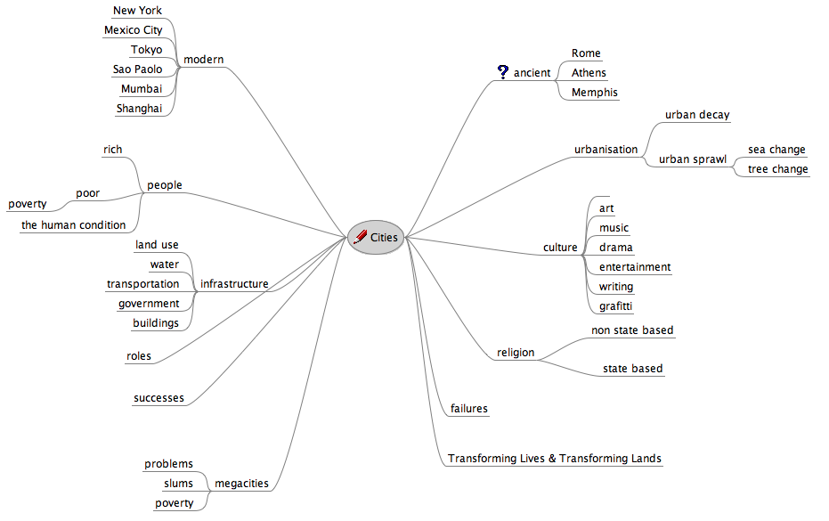
Integration of Information Technology ~ Suggested activities ~ Possible task list

Tool | Contribution | Description of activity
Inspiration &  Swicki | Mind Map  Customised Swicki Search Engine  Group work ~ collaborative  Assessment ~ formative | Ongoing process ~ Developmental ~ Malleable over time  - Mind map evolves over time  - Key points incorporated into Swicki search engine that is specifically designed for the ITLU  - Swicki Search engine embedded in specific ITLU wiki, blog or web site
Wikispaces  Jaiku | Topic specific web page(s)  Group work ~ collaborative  Assessment ~ formative | Students create a Wiki page on a topic that is a subset of the broader ITLU  Students hyperlink content to other Wikis and external web sites.  Sub topic may be an area of deeper interest or fascination for the student.  Jaiku acts as a What’s New for the entire project and is embedded in the blog and wiki.
Keynote or  Powerpoint | ITLU Scrapbook  Assessment ~ formative | Students utilise Keynote or Powerpoint as a scrapbook or clipboard for their ideas, images and notes
iWeb | Web page(s)  Timeline  Assessment ~ formative | Students create a web page(s) on a topic that is a subset of the broader ITLU  Students hyperlink content to other pages and external web sites.  Sub topic may be an area of deeper interest or fascination for the student.
Comic Life | Comic Strip(s)  Group work ~ collaborative  Assessment ~ formative | Students recreate conversations relating to the topic:  - Arguments between politicians and constituents  - Conversations between opposing interest groups  - Arguments between developers and residents  - Conversation between a driver and a cyclist  - Conversation between inanimate objects such as a car and train, car and bicycle, road and footpath, cloud and smoke, water and oil.

Tool | Contribution | Description of activity
Photoshop | Graffiti Wall  Assessment ~ formative | Create a graffiti wall in a modern city and an ancient city  - How are they similar and why are they different?  - Publish the mosaic for display within the school
Blog  Jaiku  Google Reader | eduBlogs  Online blog of the City Planner  Assessment ~ summative | Diary of a city dweller in New York, Mumbai, Mexico, Sydney, ancient Rome and/or ancient Tenochtitlan. Diary could deal with the:  - highs and lows of city living  - urban high rise  - suburban slums  - the rich  - the poor  - music, entertainment and the arts  - transport & infrastructure  Concludes the blog with a final report on the future direction of the city  Jaiku acts as a What’s New for the entire project and is embedded in the blog and wiki.  Blogs are monitored via Google Reader
Mozo Dojo | Urban Mosaic  Group work ~ collaborative  Assessment ~ formative | Create a mosaic of images that reflect the face(s) and issues of urban society… in the past and in the present  - Publish the mosaic for display within the school
Twitter | Twitter Challenge  Assessment ~ formative | Students are sent a fertile question at random time to answer.  - The students send in their answer via Twitter to the ITLU Twitter page.  - Responses must be less than or equal to 140 characters in length  - Point score system for Twitter responses  Their Twitter badge can be embedded in their blog or web page

Tool | Contribution | Description of activity
Podcast Maker  GarageBand  Quicktime  and/or  Audacity | Interview with a city dweller past and present  Life in the city ~ past and/or present  Group work ~ collaborative  Assessment ~ summative | Students storyboard a 5 minute podcast segment that will consist of one or combination of the following elements:  - Interview with a city dweller (politician, town planner, resident, visitor, etc)  - Interview with an animal or bird (rat, sparrow, hawk, etc)  - City noises  - City/urban music  - City fauna
Google Maps  Google Earth | Embedded “live” and interactive maps in blog, web site or wiki  Assessment ~ formative | Students are to locate the positions of a selection of major cities.  Using the “Link to this page” feature of Google Maps they are to modify the map and then embed the map into their blog or wiki page.  They are then required to annotate the map describing:  - The relationship between the terrain and the urban development.  - Location of key features (CBD, retail, industrial, residential, slums)  Relevant Google Maps can be embedded in blog and wiki
Excel or  iWork Numbers | Spreadsheets and charts  Assessment ~ formative | Students are to create graphs and charts that illustrate  - Urban and rural populations of the world 1950 to 2030  - Urban and rural populations of developed and developing countries  - Growth of the world’s largest cities 1950 to 2015 (projected)  Each chart is analysed and discussed…  - What do the charts predict for the future?

Integration of Information Technology ~ some thoughts

The information technology and curriculum integration process should allow students to develop within an environment that meets the following criteria...

- The application of the technology should match the desired, specific curriculum outcomes
- The tool’s learning curve should be short or non-existent
- Development should be seamless for the students
- The projects created by the students should be easily customisable
- The projects should be interoperable
- The projects should be re-usable
- Subsequent cohorts should be able to pick up the projects and run with them

Creation of the various contributions and the major ITLU project should be seamless for the students. It is the understanding that is important. The tool should not get in the way of the process.

Assessment Overview

Formative | Summative
Mind Map  Wikipage or web page (timeline data)  Issues Mosaic  Twitter Challenge Scores  Graffiti wall  Mapping task  Chart analysis activity  Comic Life project | Evaluation of City Planner Diary and Final Report on Future Directions  - Teacher evaluation  - Self evaluation  - Peer evaluation  Podcast Interview
Marking grid and criteria developed in tandem with other learning advisors.
Were outcomes met? If so, to what extent?
Is there evidence of learning? If so, to what extent?

