Diigo

Introduction

What is Diigo? Well, the main page for Diigo proudly declares that it is a “powerful research tool and a knowledge sharing community”. The forces behind Diigo also refer to it as a “Diigo is two services in one -- it is a research and collaborative research tool on the one hand, and a knowledge-sharing community and social content site on the other”. [http://www.diigo.com/about] It is certainly an interesting tool. What does it do?

Diigo allows you to save and categorise your bookmarks online. It also allows you to join like-minded groups that share their bookmarks. You can search these bookmarks to locate popular or highly recommended sites on a particular topic or area of research. It is difficult to define Diigo. It is different things to different people. It has a rich set of features. One or two features may be all you need to make practical use of the tool?

How do you say Diigo? Why did they call it Diigo? As they state on their About page… “It is pronounced as Dee'go. The name "Diigo" is an abbreviation for Digest of Internet Information, Groups and Other stuff." [http://www.diigo.com/about]

Getting Started

To get started with Diigo type in the following url into a web browser. This can be Internet Explorer, Firefox, Safari, Opera and so on*. It does not matter whether you are using a PC with Windows or Vista. You could be using a Macintosh. It makes no difference. Concerns regarding operating systems and compatibility are no longer an issue with these online tools. It is liberating just to think of that. Type in the following Internet URL or web address in the address field of the browser.

http://www.diigo.com/

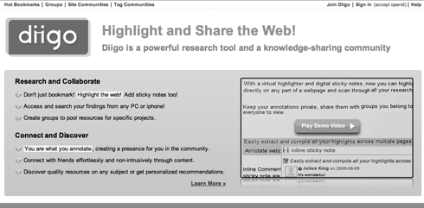
[*I do, however, recommend Firefox. It has some good security features.]
Signing Up

You can click on the large “Join Now” button on the main window or click on the Join Diigo link located in the upper right hand corner of the screen. Once you have clicked on that link you will be taken to the screen illustrated below.

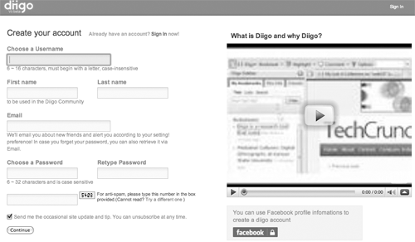

You need to complete a number of details including these:

Choose a username | Choose something that is meaningful and purposeful. It may be a nickname. I actually use a version of my name quite often. I want people to know who I am. Others prefer a username that may be a little cryptic in order to preserve anonymity.
First name  Last name | I use my own names. That is up to you. My identity on the net is ‘out there’ however I am being circumspect regarding my exact address and age as much as possible.
Password | Create a good password that is meaningful only to you and that you can remember. I personally use a related sequence of passwords for my various Internet accounts. There is one rule that I always follow. I NEVER use my bank pin or banking password for any Internet related account. The PIN and password that I use for my bank are very different and totally unrelated to anything that I do on the Internet.
Email address | You may use a private email address such as a Gmail account. You may use your work email account. That is entirely up to you.

Once you are satisfied with the details that you have entered follow the steps that will appear after completing this page. You will eventually reach your Dashboard.
Signing In

If are already a member of the Diigo community you simply need to sign in. Click on the Sign In link.

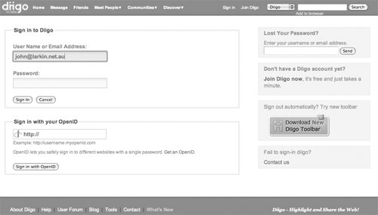

Simply enter your username or email address followed by your password.

The Dashboard

Once you have signed in or joined Diigo you will be taken to the Dashboard. This term is commonly used as the main entry point for many tools on the Internet, blogs in particular.

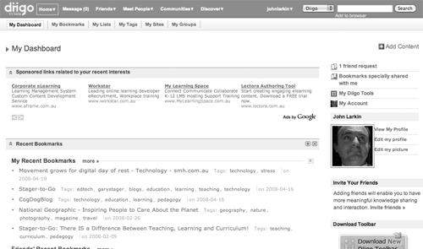

Unfortunately, you will notice that Diigo is spoiled with advertising. It is a free service so I guess we shall have to tolerate it.

The Dashboard features a number of defined areas. They include:

- The menubar across the top of the window
- Add Content button [Add content to your Dashboard]
- Your bookmarks [Note: This can be deleted]
- Friends’ recent bookmarks [Note: This can be deleted]
- Friends’ activities [Note: This can be deleted]
- Comment Wall [Note: This can be deleted]
- Recent Visitors to My Profile [Note: This can be deleted]
- Unread Messages [Note: This can be deleted]
- Sidebar [Links to you Tools, Account details and Profile]

The Menubar allows you to explore Diigo.

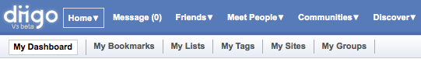

You can use the Friends link to search for existing contacts that are using Diigo. You can also invite others to join Diigo. You can also search for like-minded users of the tool by using the Meet People link. Simply explore each option and carefully check the profiles of users that you feel may be useful in forming a connection.

The Communities link is quite useful. There are a number of Diigo groups that are focused on education. You can search for groups interested in specific topic areas. You can then join that group and share in the bookmarks. It is quite useful. More on this later.

The Discover link takes you to a page that allows you to explore a variety of bookmarks. Quite often they are closely related to your own interests. The best aspect of the Discover page is the ability to set up a Watchlist alert system where bookmarks categorised with a particular tag defined by yourself will flagged and added to your Watchlist. See below.

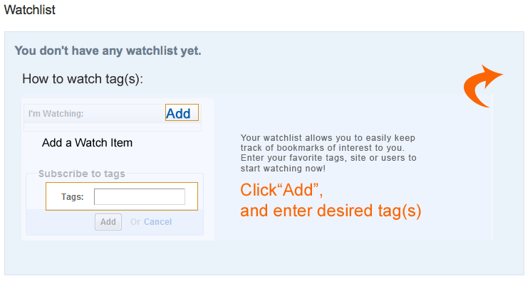
Another link in the menu bar worth mentioning is the Messages link. The messages page allows you to send messages to all your ‘friends’ on Diigo. This will work better if you have a large number of friends. You may pose a question regarding a particular resource or problem. A friend may then respond with a solution and relevant bookmarks for you. See below.

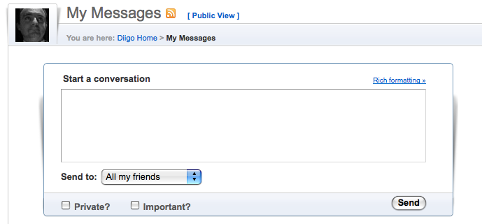

When you are viewing your Dashboard the second row of the menubar features a number of important links. They include:

- My Dashboard
- My Bookmarks
- My Lists
- My Tags
- My Sites
- My Groups

What does each do?

My Bookmarks

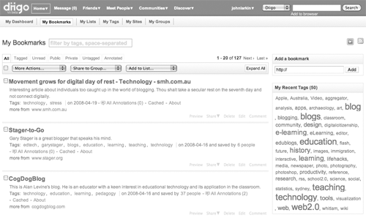

The Bookmarks page is rich with features. First of all you can select one or more bookmarks by clicking on the button alongside each bookmark. You can select all the bookmarks if you wish. There are a number of actions or options you can apply to a bookmark once it is selected. They include:

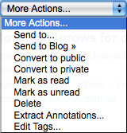 | More actions… As you can see from the drop down menu you:  - Can “Send” the bookmark to your friends, together with a note.  - You can send the bookmark to your blog where it will appear as a blog post.  - You can change its private or public settings.  - You can change its read or unread setting.  - You can delete  - Extract any annotations  - You can edit any tags applied to the bookmark
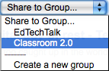 | Share to Group…  You can share your bookmarks with any group that you have joined.
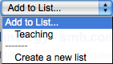 | Add to List  This menu item allows you to add bookmarks to your Lists
Tag Cloud  The Bookmarks page also features a Tag Cloud.  This illustrates recently used tags applied to your Bookmarks.  The size of a tag reflects the relative number of bookmarks that have been allocated that tag. |  | 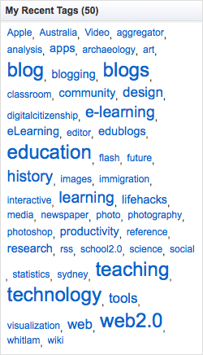

Each bookmark is also equipped with a number of options and features.

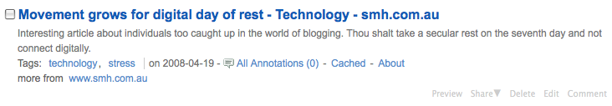

- Clicking on a bookmark will take you to that web site.
- The tags that have been allocated to the bookmark are listed. Clicking on the tag, for example ‘technology’ will list all the bookmarks allocated that tag by yourself.
- You can view any annotations. By clicking on the About link you can view statistics that relate to the Bookmark.
- You can also Preview the web page for that bookmark.
- You can Share the bookmark with other friends.
- You can Edit this bookmark. This is quite significant. It allows you edit all of the features of the bookmark as well as adding to a list or seding it to friends or groups.

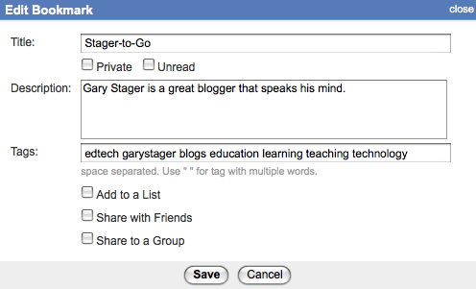
My Lists

Diigo allows you to create lists of particular bookmarks. This may be particular useful if you are teaching a particular topic or researching a specific field. You can house the bookmarks on this page. An example is illustrated below.

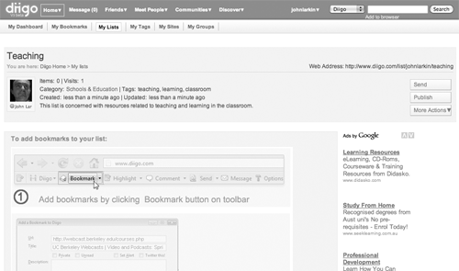

It is easy to create a new list page. Simply click on the Create a new list button.

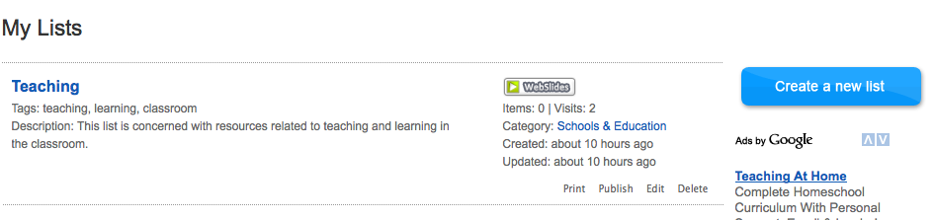

Once you have clicked on the button you will have the opportunity to specify the details for the List page. Each List page has its own specific web address. You can customise the web address.

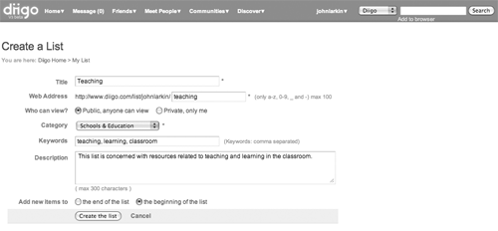
My Tags

This page lists all your tags. Clicking on a tag will bring up the bookmarks allocated that tag. You can also sort the tags.

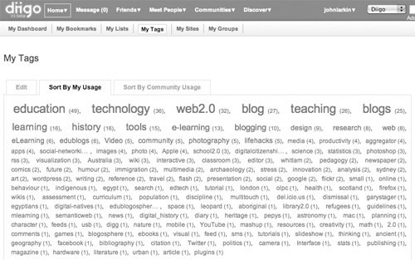

My Sites

This page features links to the sites that you have bookmarked most frequently. For example you may have bookmarked a large number of articles at National Geographic. It will feature on this page.

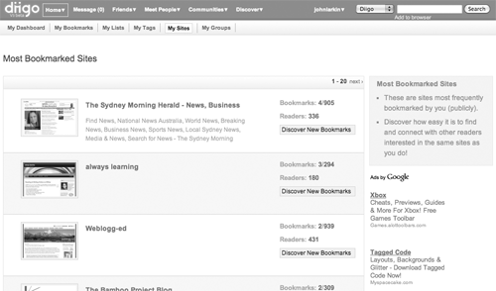

My Groups

This is a powerful aspect of Diigo. It is possible to join groups and share the bookmarks created by members of the group. You can also share your bookmarks with the group.

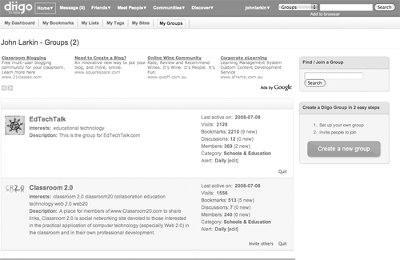

You can participate in Discussions, review the Bookmarks, and review the Member profiles. Clicking on the Category link will take you to a list of similar groups.

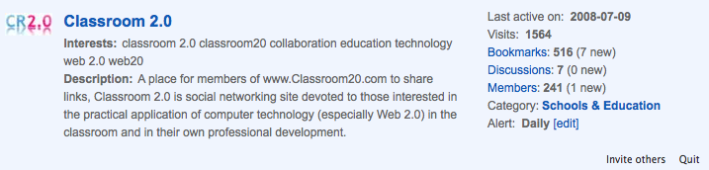

Bookmarks created by the group can be sent to you via email. You can change the regularity of the alerts by making a selection from the Alert menu. A sample email is shown below.

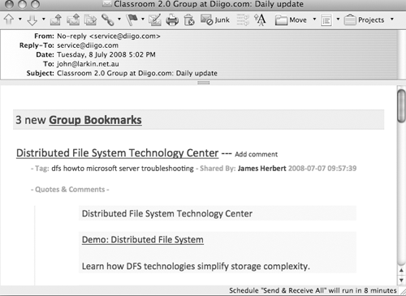
You can search for groups via a variety of different methods. You can select Groups from the Communities menu.

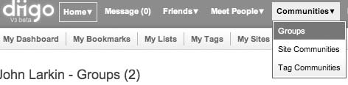

You can browse for groups. You can also search for groups by using the Search field.

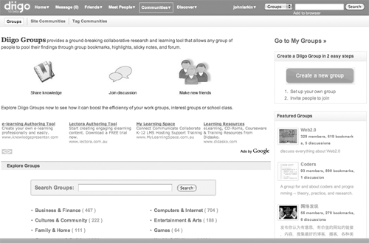

The results will appear as follows.

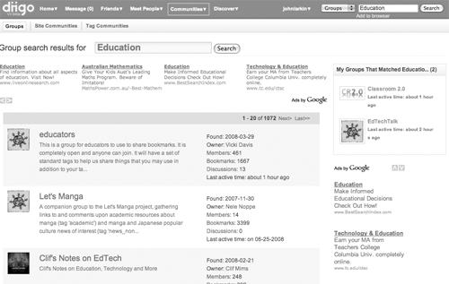

You can review each group and choose to join a group.

Personal settings

One of the more important features of Diigo is that capability to alter the settings to meet our needs. You can access the following features from the drop down menu associated with your account name on the menu bar.

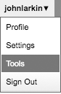

Let’s look at each entry in turn.

Profile

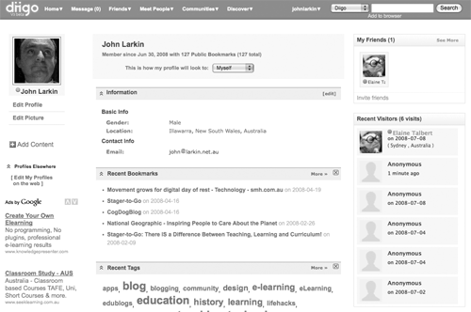

This page provides other Diigo users with limited information about you as well examples of your bookmarks and groups that you have joined. Your email address is not made public. Your email is visible because you, as a user, have signed in to Diigo.

You can edit the Profile. I recommend that you only enter minimum details. Do not enter your age or exact address. You can also add a picture.

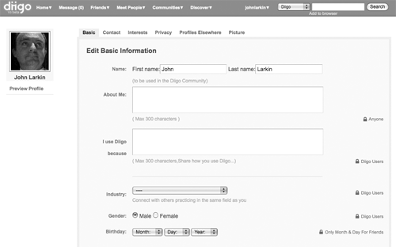

You can also edit your contact details, interests, profiles elsewhere and picture by clicking on this tabs. More importantly you can edit your privacy settings. Please see the examples below.

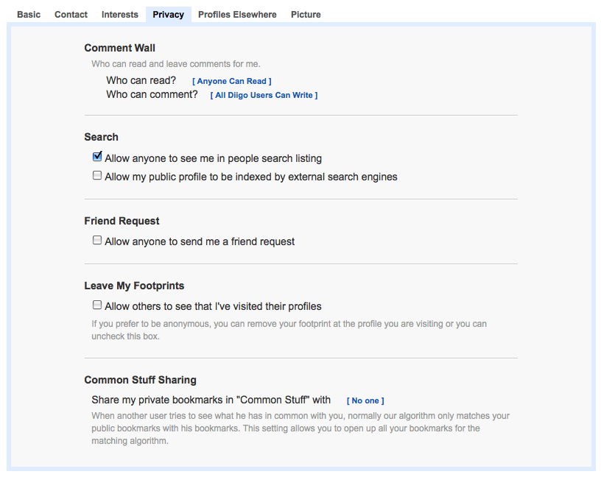

Account Settings

You can use this page to amend the following details:
- Email  - Language Preferences  - Messaging  - Viewing Preferences| | - Password  - Notifications and Newsletters  - Open ID  - Delete Account

Amend the settings to meet your needs.

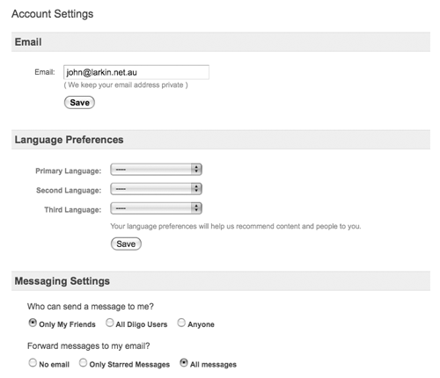

Tools

There is a wide variety of tools available in Diigo. The best way to discover each tool is to explore each that is available. Three tools stand out from the rest:

- The Diigo Toolbar
- Daily Blog Post
- Save Elsewhere

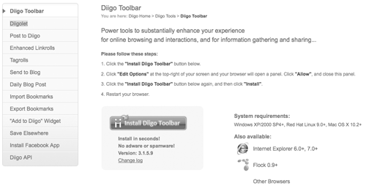

The Diigo Toolbar

This toolbar can be added to your web browser. An example is shown below. It gives you access to nearly all the features of Diigo from within your browser.

You can perform all your actions from this Toolbar. As you can see from the screen shot the drop down menu includes a variety of useful features.

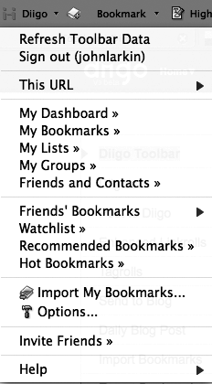 | You can bookmark your pages, highlight and add comments to pages. You can also send pages to friends in Diigo.  It is worthwhile to explore each feature in order to learn its characteristics in detail.
Daily Blog Post

If you possess a blog you can set up Diigo to send your Bookmarks to your blog where they will appear as a post. It can augment your blog and allow your blog readers to tap into your bookmarks. This can be quite a powerful adjunct to your education networking efforts.

Select Daily Blog Post from the Tools menu and the following window will appear.

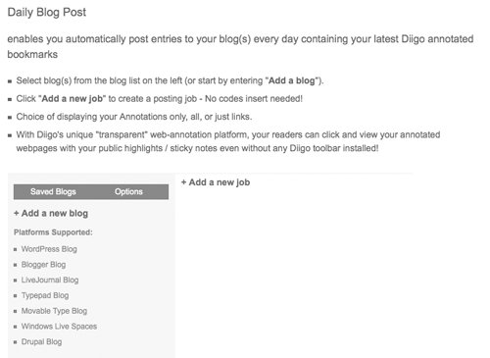

Click on Add a new blog. The following field will appear.

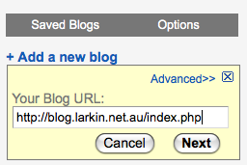

Enter the full address of your blog. An example is shown for you. Click on the Next button.

The following entry fields will appear.

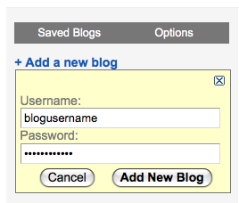

Enter the Username and Password for your blog. Click on Add New Blog. The following record of the newly added blog will appear.

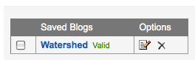

Click on the selection button alongside the Blog title to reveal the choices shown below.
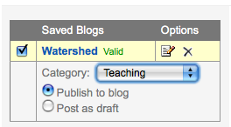

Select the category for your blog post and choose whether or not the blog post will be published immediately or saved as a draft for later checking and editing by you.

Now, click on the Add a new job link that appears on the same page. The following data entry fields and choices will appear.

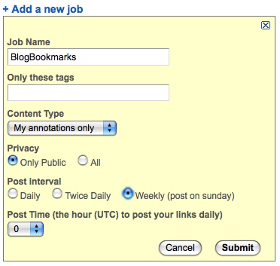

Complete the fields and make your selections. Then click on the Submit button. The job has now been completed and will be listed on the window. See below.

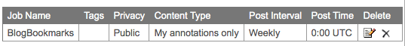

Saving your bookmarks Elsewhere

If you have another social bookmarking account such as del.icio.us you can also automatically save your bookmarks to that account. Select Save Elsewhere from the Tools menu. The following page will appear.

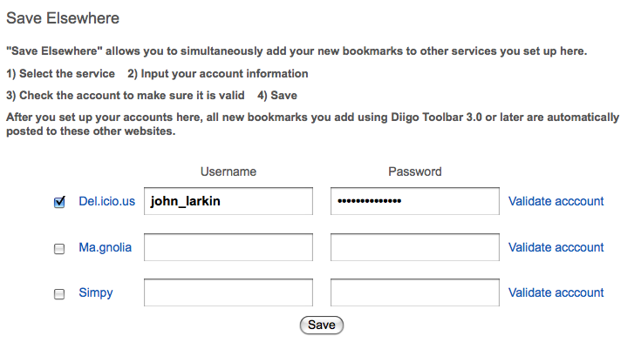

Select the type of account and enter your username and password details. Click on the Validate account link. If the account is validated the following validated message will appear.

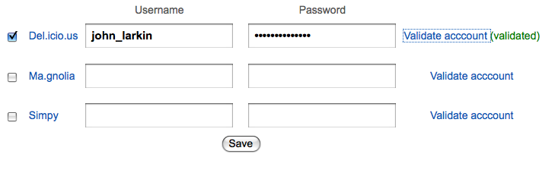

Then click on the Save button. The following confirmation will appear.



